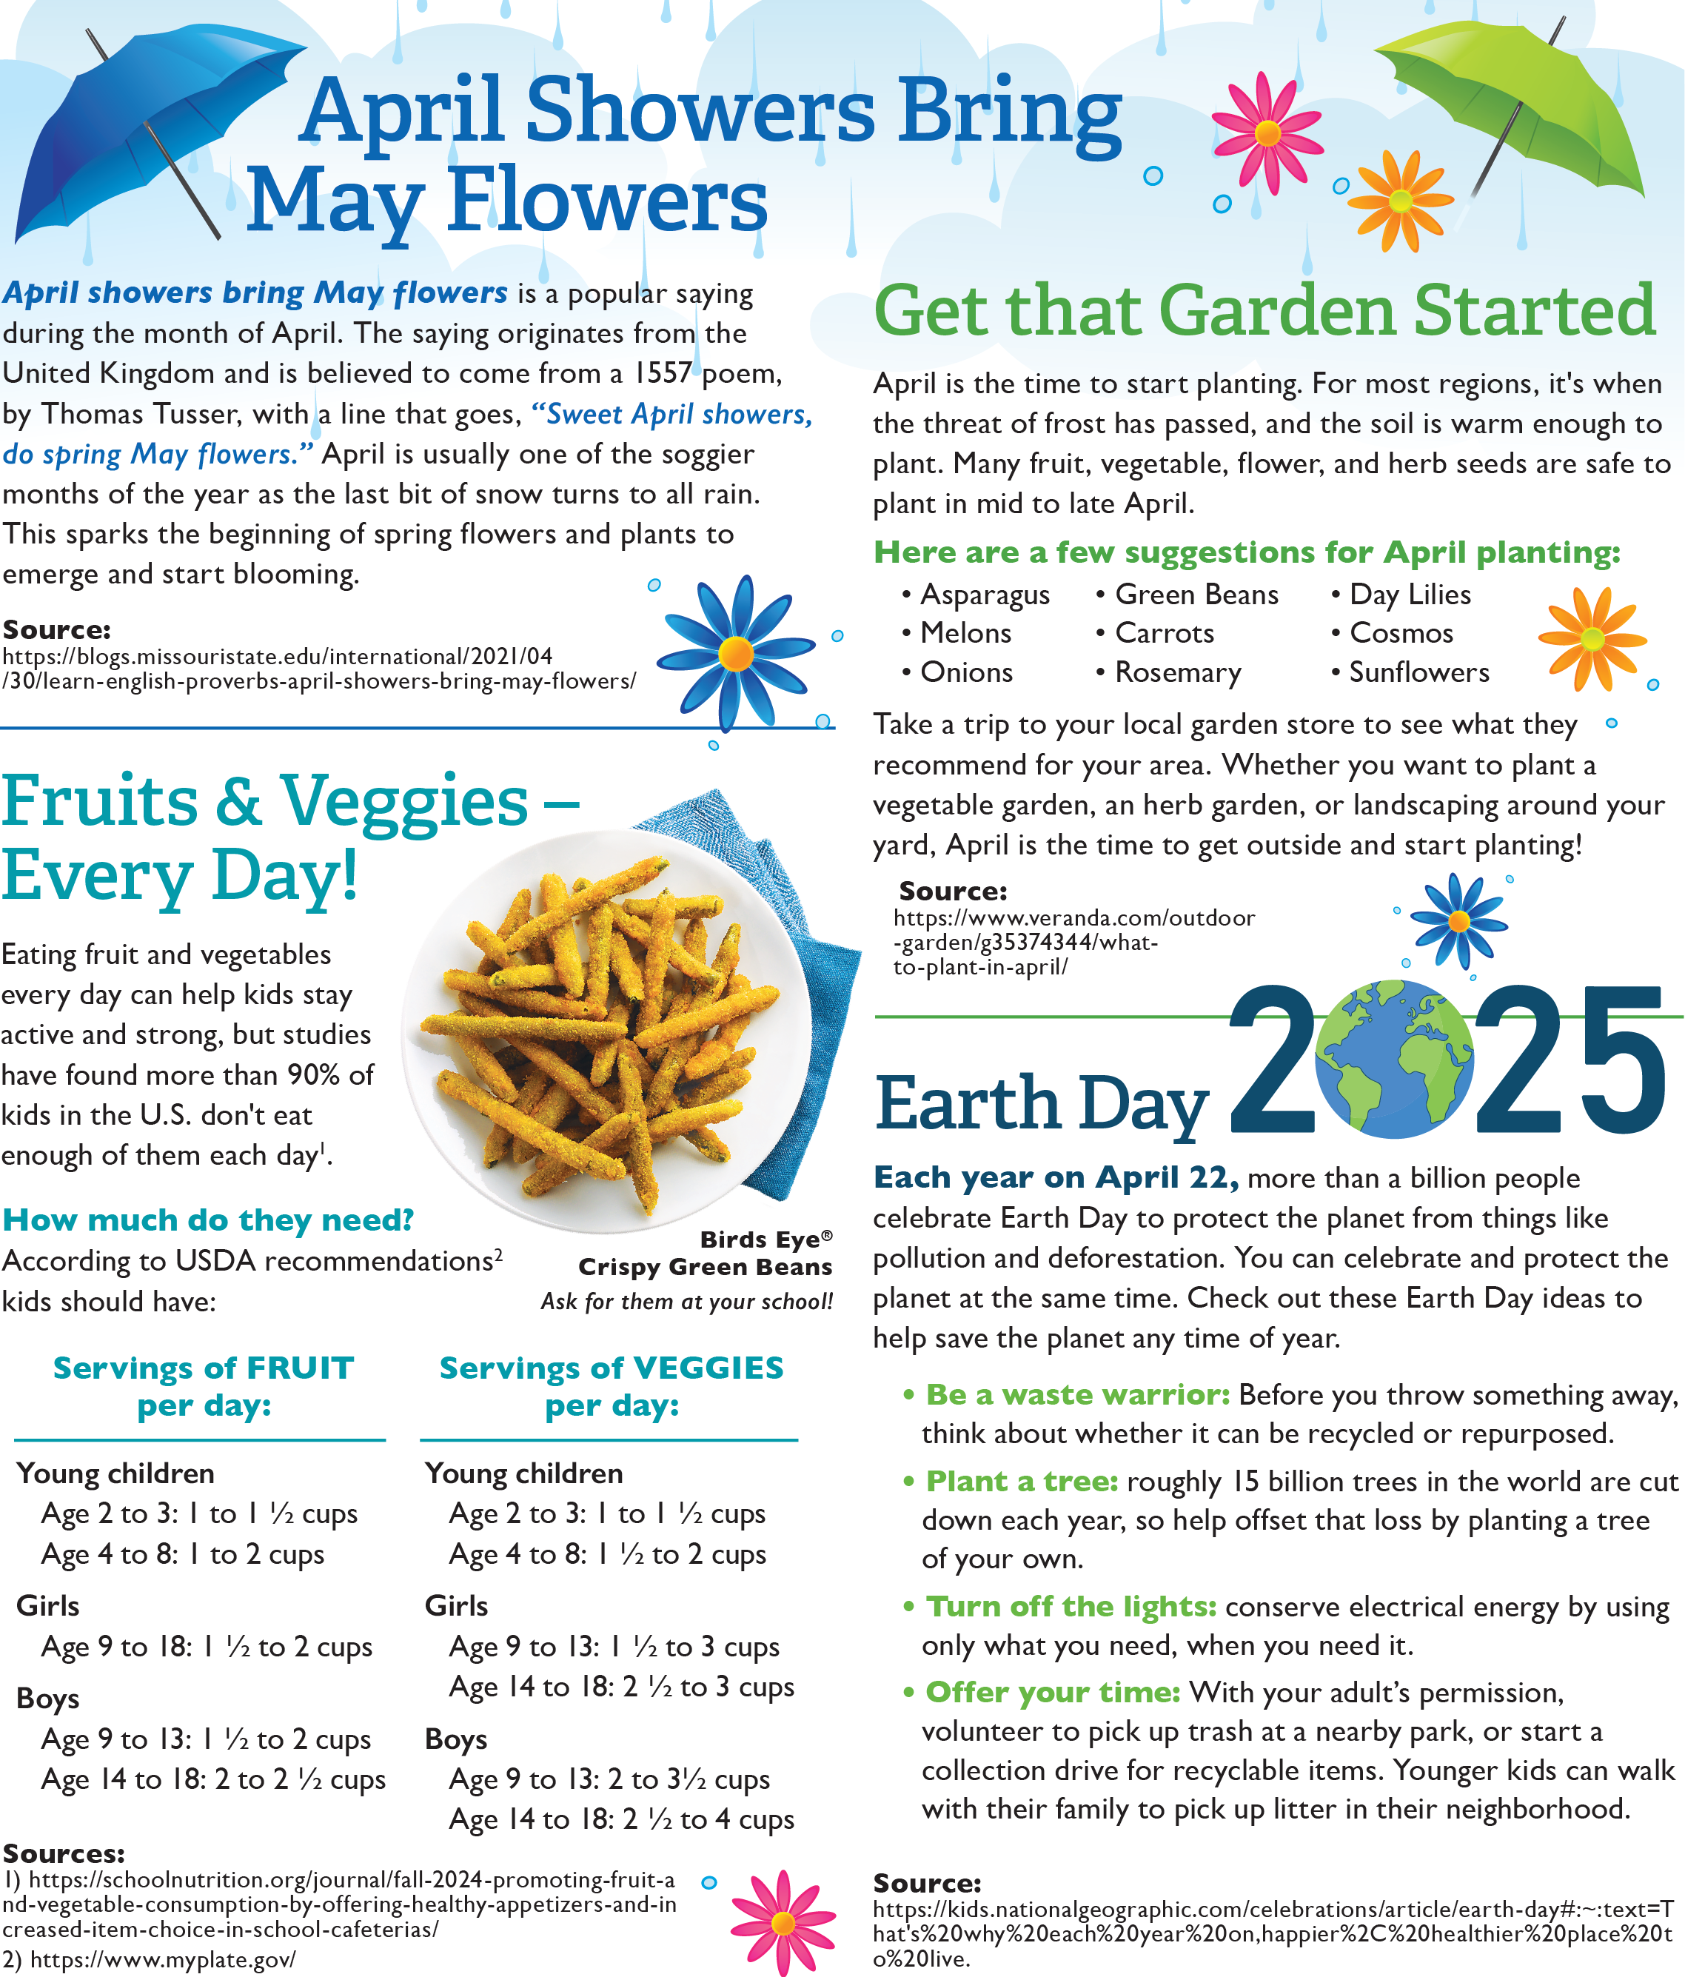

<https://blogs.missouristate.edu/international/2021/04/30/learn-english-proverbs-april-showers-bring-may-flowers/>

<https://www.veranda.com/outdoor-garden/g35374344/what-to-plant-in-april/>

<https://rethinkschoolmeals.com/>

<https://www.conagrafoodservice.com/>

[https://kids.nationalgeographic.com/celebrations/article/earth-day - :~:text=That's why each year on,happier, healthier place to live](https://kids.nationalgeographic.com/celebrations/article/earth-day" \l ":~:text=That's%20why%20each%20year%20on,happier%2C%20healthier%20place%20to%20live)

<https://www.myplate.gov/>

<https://schoolnutrition.org/journal/fall-2024-promoting-fruit-and-vegetable-consumption-by-offering-healthy-appetizers-and-increased-item-choice-in-school-cafeterias/>