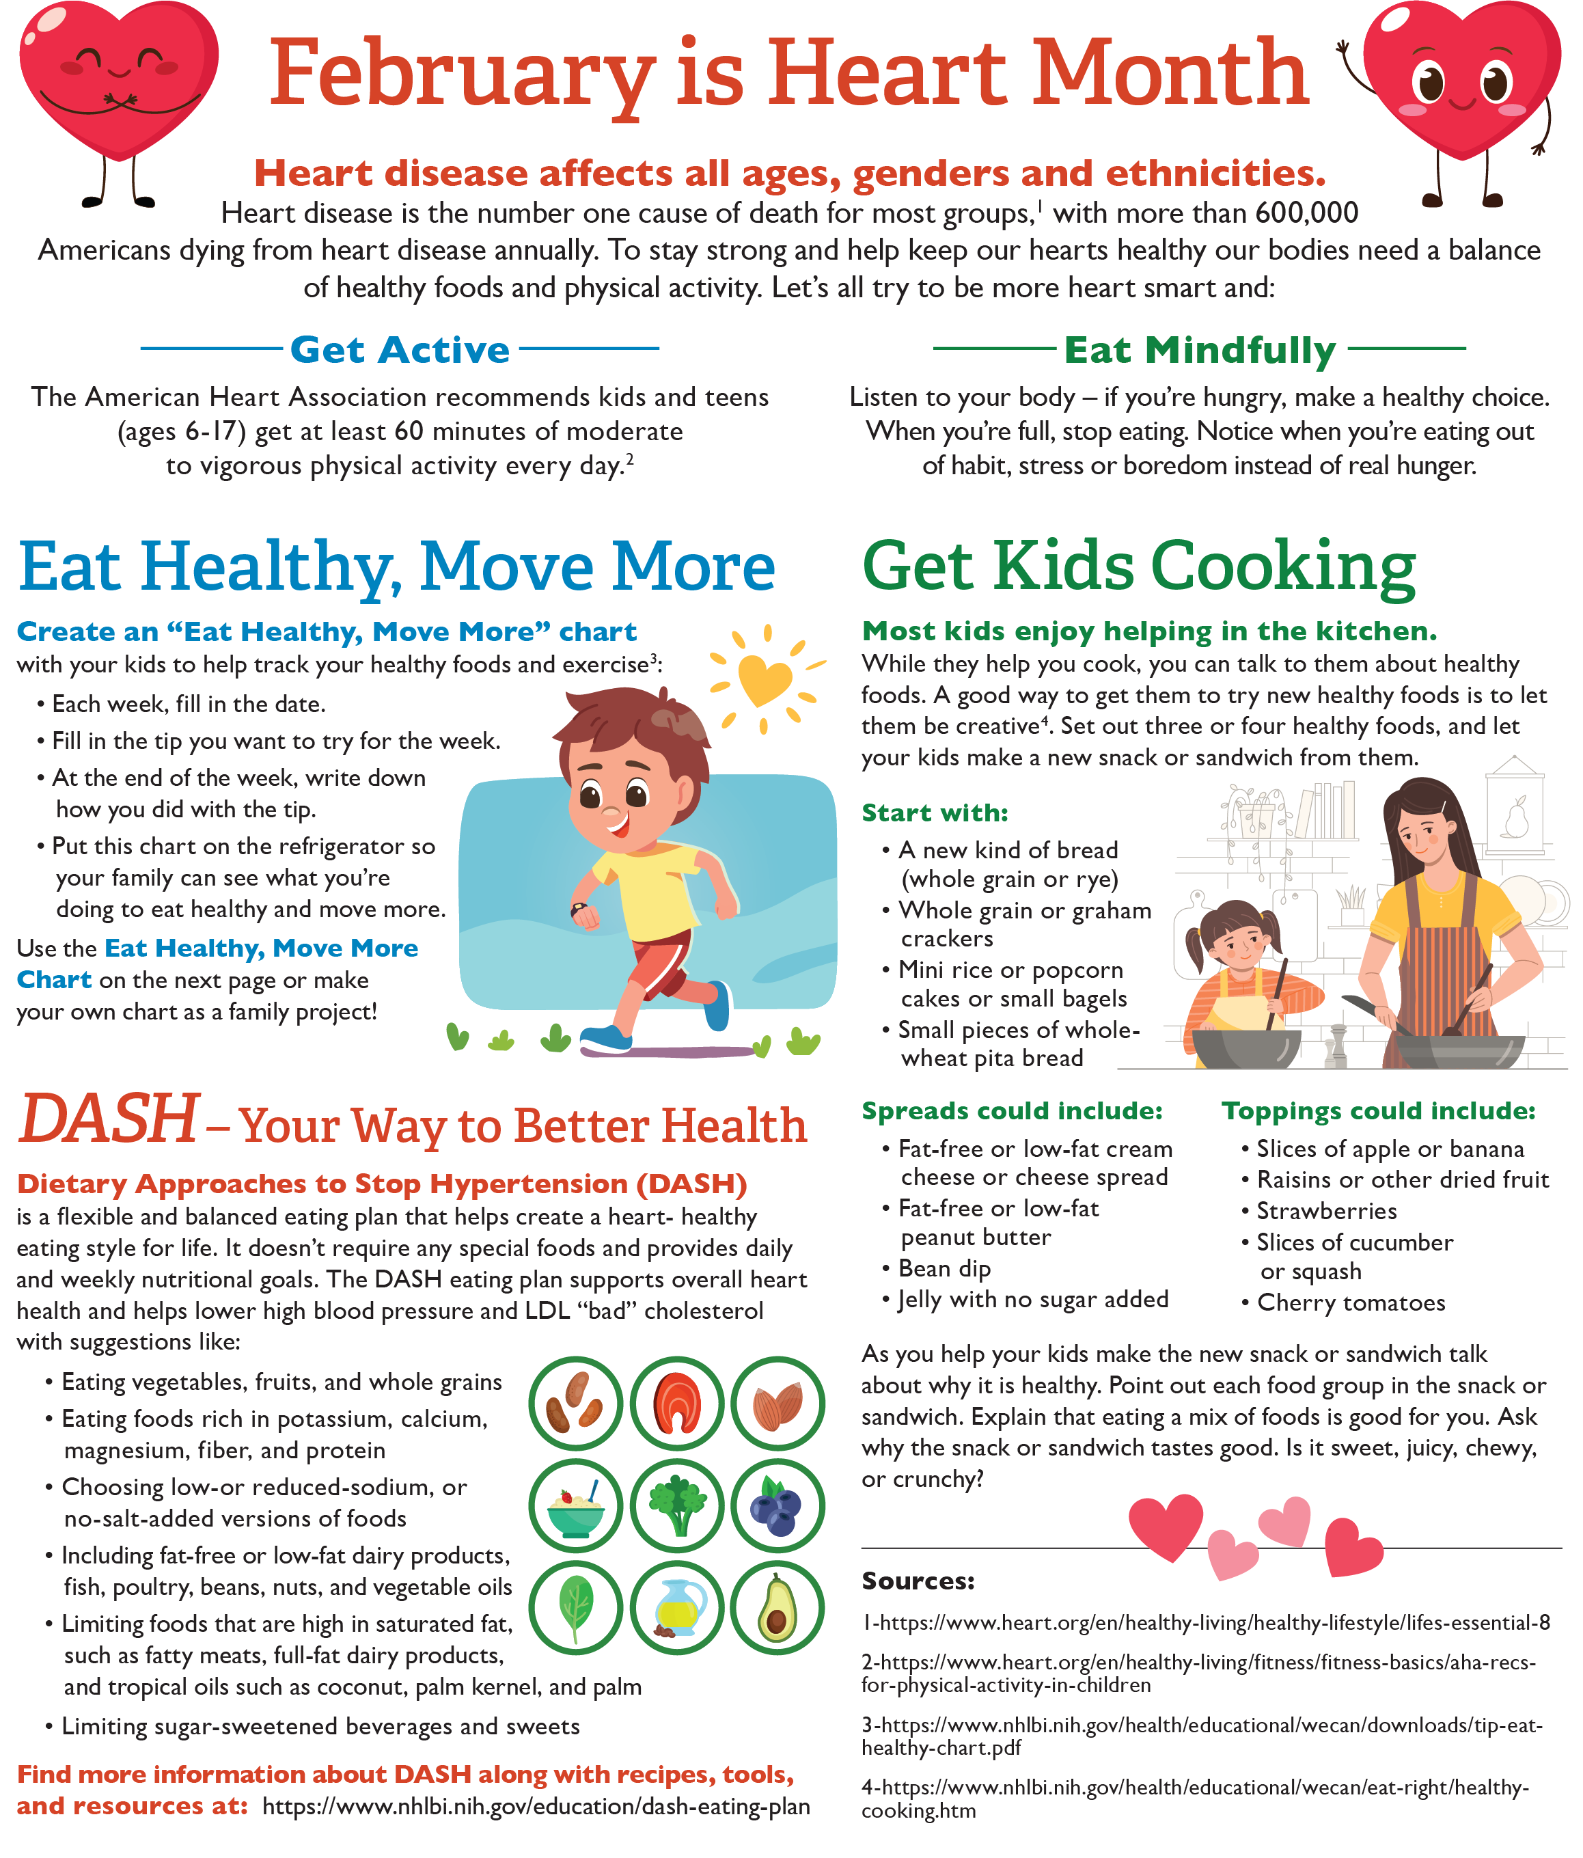

<https://www.heart.org/en/healthy-living/healthy-lifestyle/lifes-essential-8>

<https://www.heart.org/en/healthy-living/fitness/fitness-basics/aha-recs-for-physical-activity-in-children>

<https://www.nhlbi.nih.gov/health/educational/wecan/downloads/tip-eat-healthy-chart.pdf>

<https://schoolnutrition.org/mwsl/>

<https://www.nhlbi.nih.gov/education/dash-eating-plan>

<https://www.nhlbi.nih.gov/health/educational/wecan/eat-right/healthy-cooking.htm>

<https://www.conagrafoodservice.com/>

<https://rethinkschoolmeals.com/>



<https://www.nhlbi.nih.gov/health/educational/wecan/downloads/tip-eat-healthy-chart.pdf>

<https://www.conagrafoodservice.com/>

<https://rethinkschoolmeals.com/>