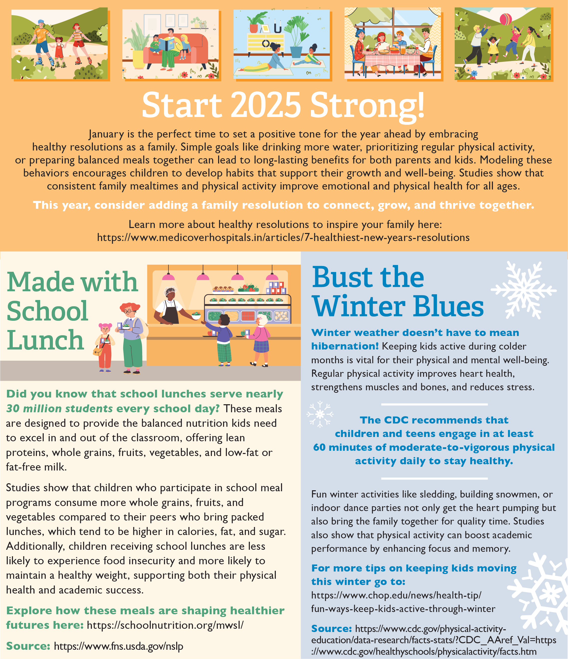

<https://www.medicoverhospitals.in/articles/7-healthiest-new-years-resolutions>

<https://www.chop.edu/news/health-tip/fun-ways-keep-kids-active-through-winter>

<https://schoolnutrition.org/mwsl/>



<https://www.conagrafoodservice.com/>

<https://rethinkschoolmeals.com/>