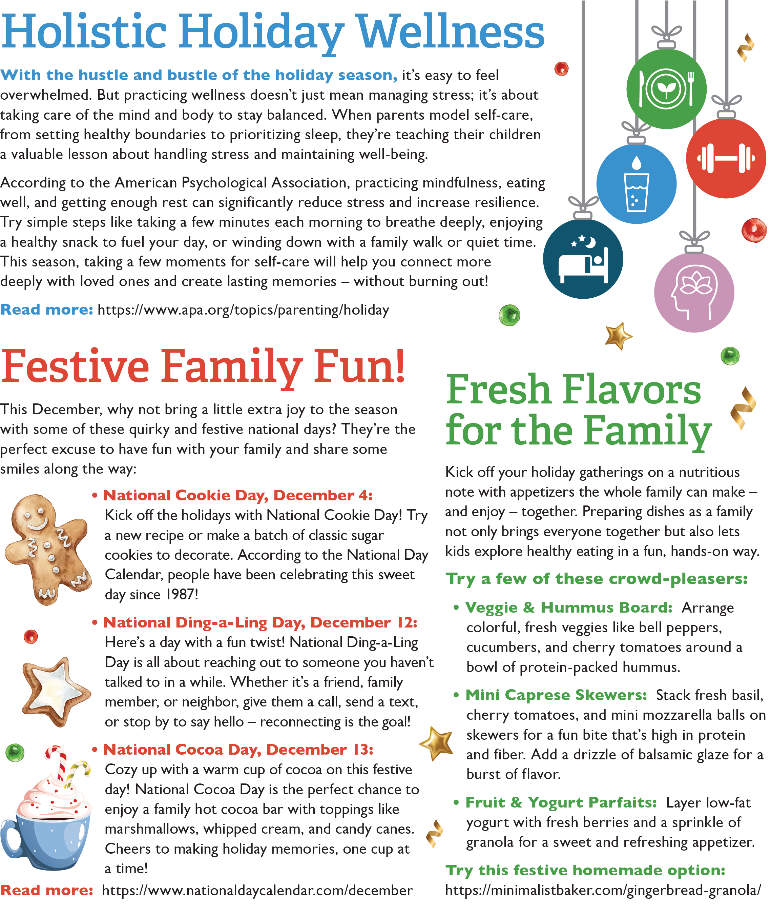

<https://www.apa.org/topics/parenting/holiday>

<https://www.nationaldaycalendar.com/december>

<https://www.conagrafoodservice.com/>

<https://rethinkschoolmeals.com/>

<https://minimalistbaker.com/gingerbread-granola/>