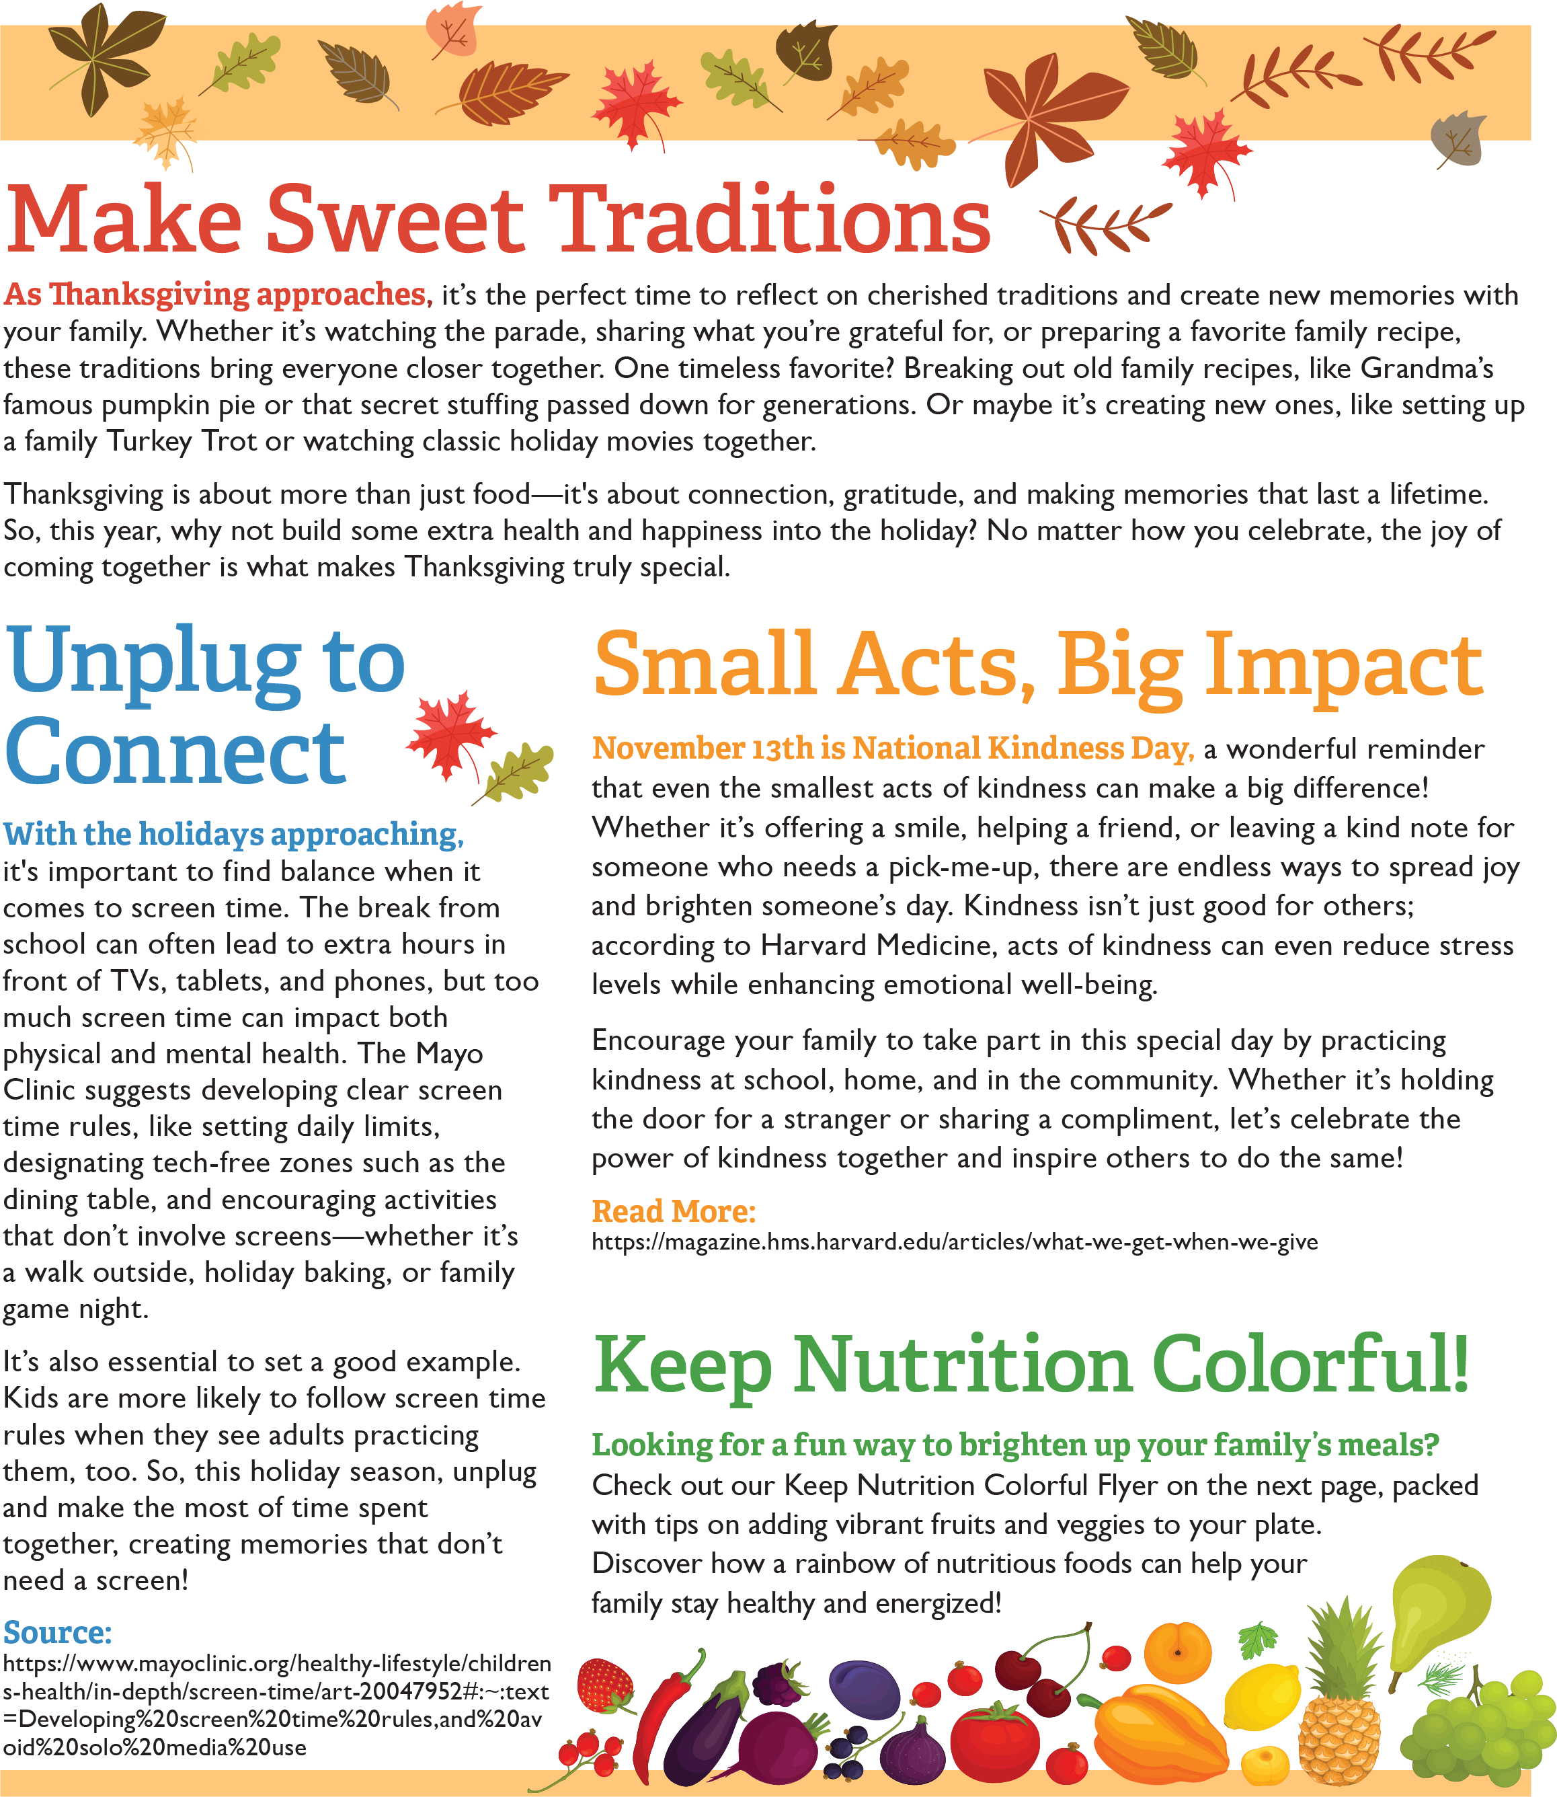

<https://magazine.hms.harvard.edu/articles/what-we-get-when-we-give>

[https://www.mayoclinic.org/healthy-lifestyle/childrens-health/in-depth/screen-time/art-20047952 - :~:text=Developing screen time rules,and avoid solo media use](https://www.mayoclinic.org/healthy-lifestyle/childrens-health/in-depth/screen-time/art-20047952#:~:text=Developing%20screen%20time%20rules,and%20avoid%20solo%20media%20use)

<https://www.conagrafoodservice.com/>

<https://rethinkschoolmeals.com/>

<https://rethinkschoolmeals.com/>