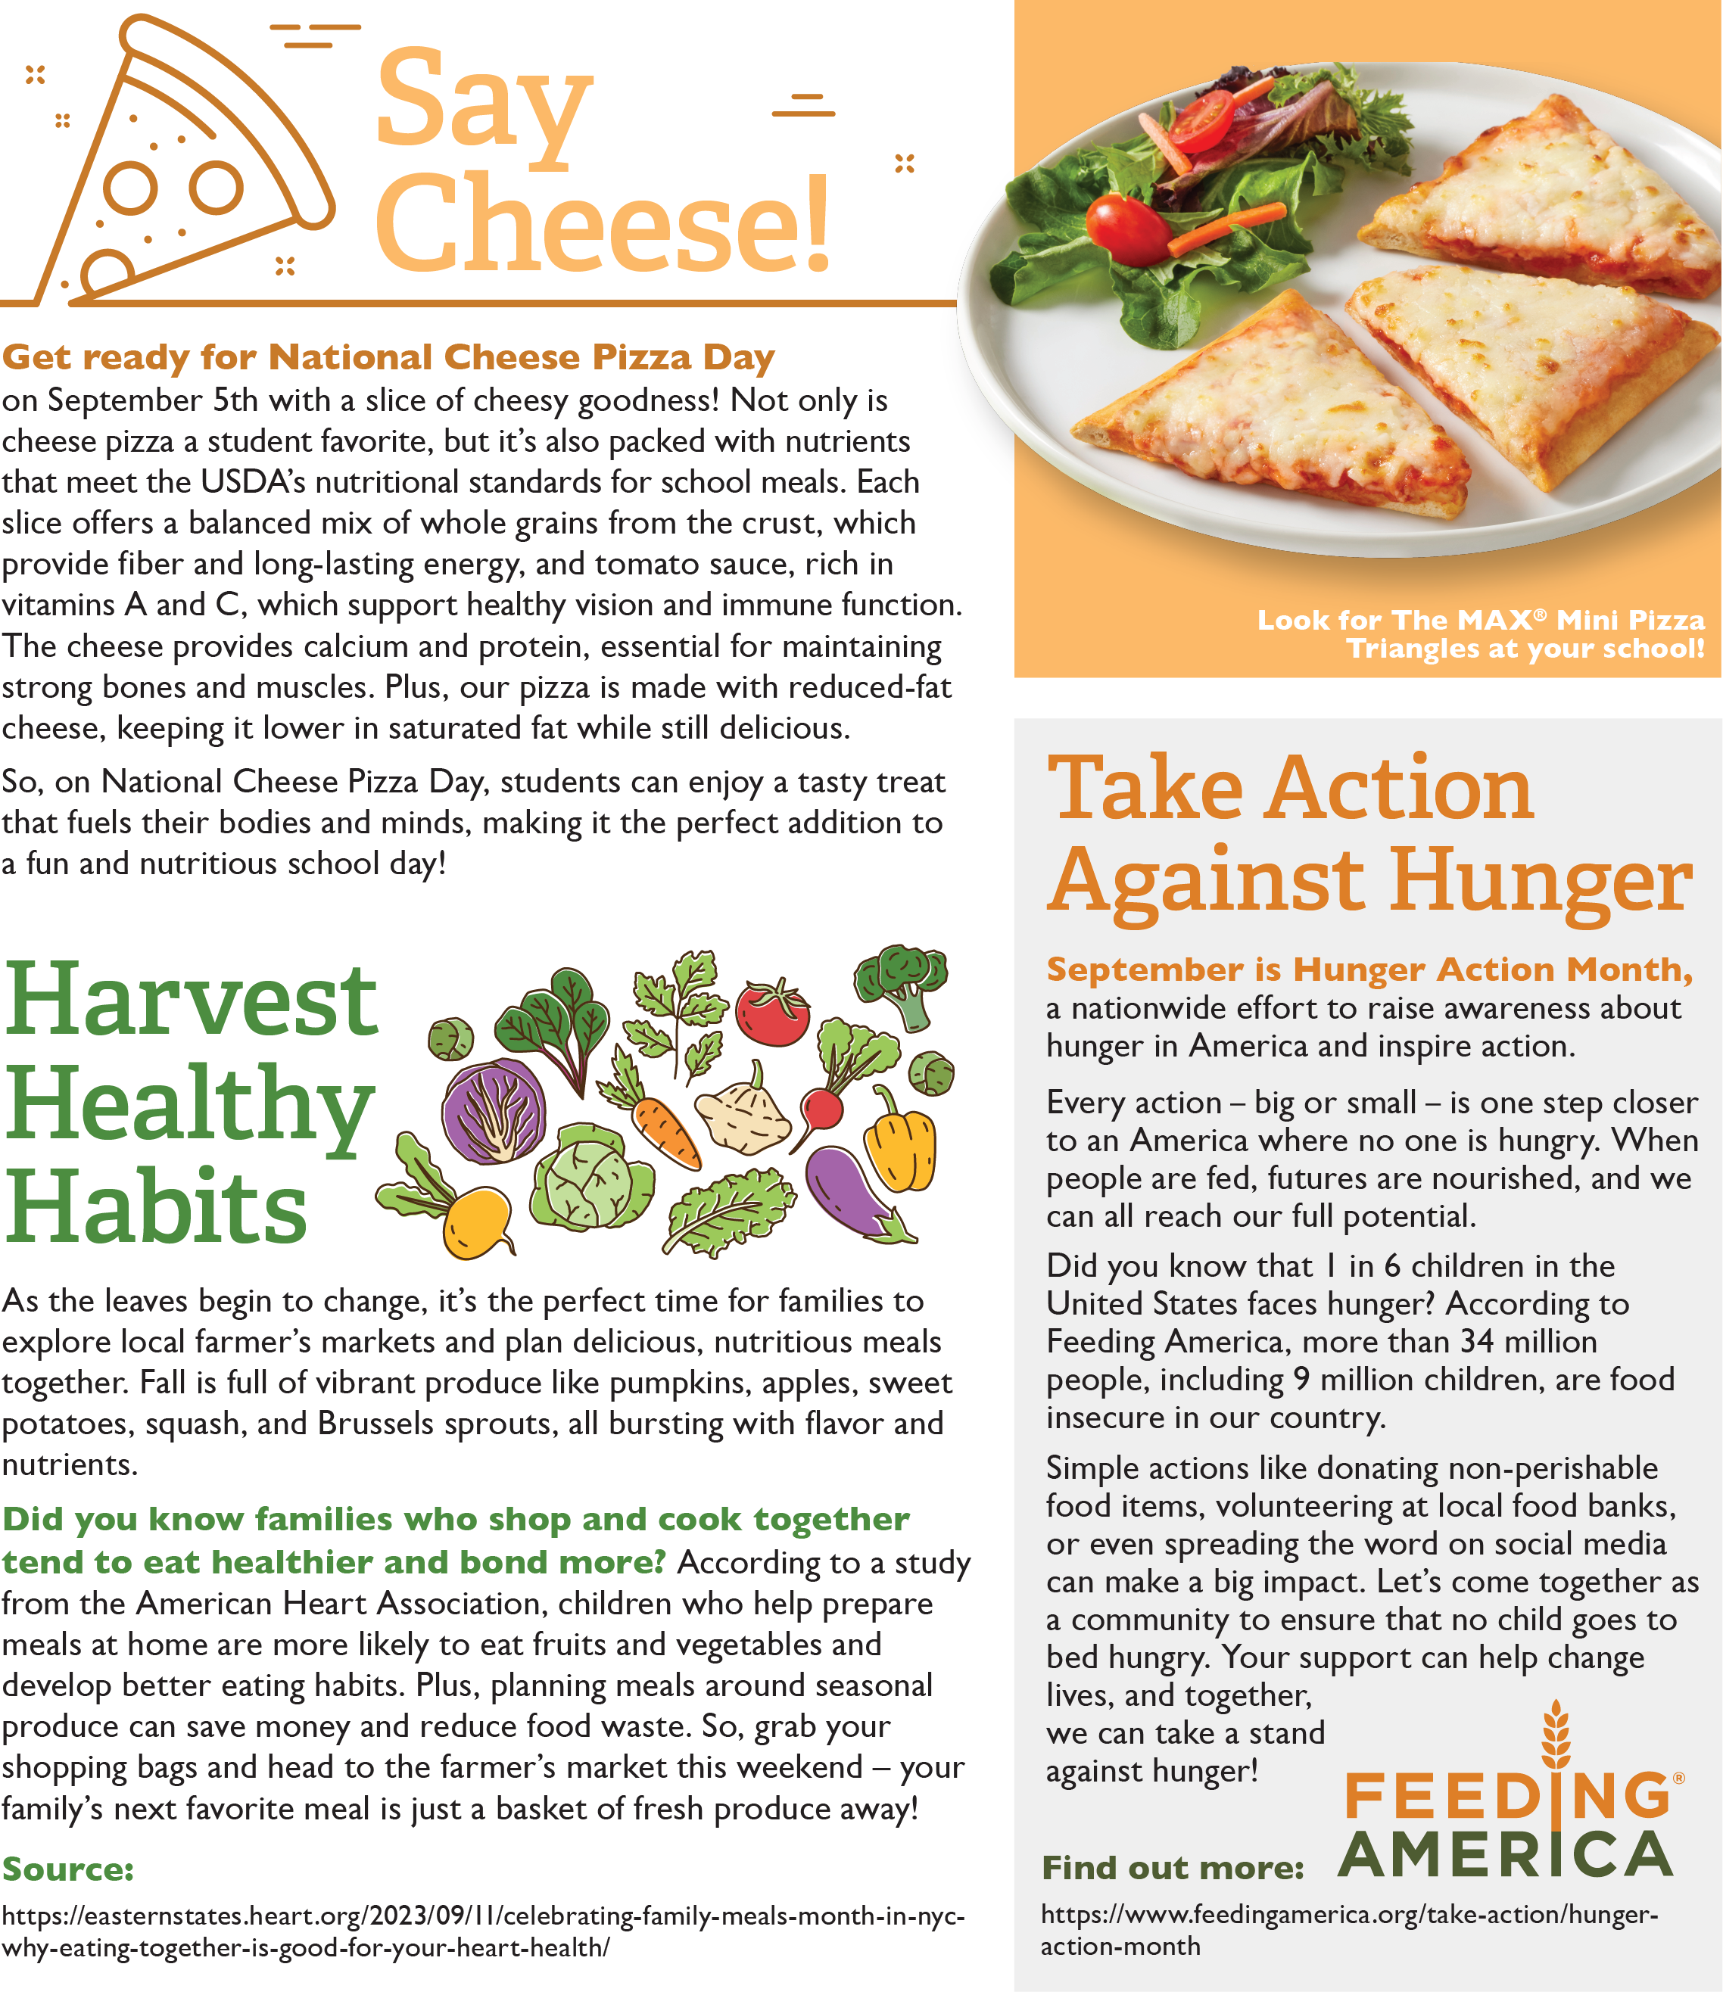

<https://www.feedingamerica.org/take-action/hunger-action-month>

<https://easternstates.heart.org/2023/09/11/celebrating-family-meals-month-in-nyc-why-eating-together-is-good-for-your-heart-health/>

<https://www.feedingamerica.org/take-action/hunger-action-month>

<https://www.conagrafoodservice.com/>

<https://rethinkschoolmeals.com/>