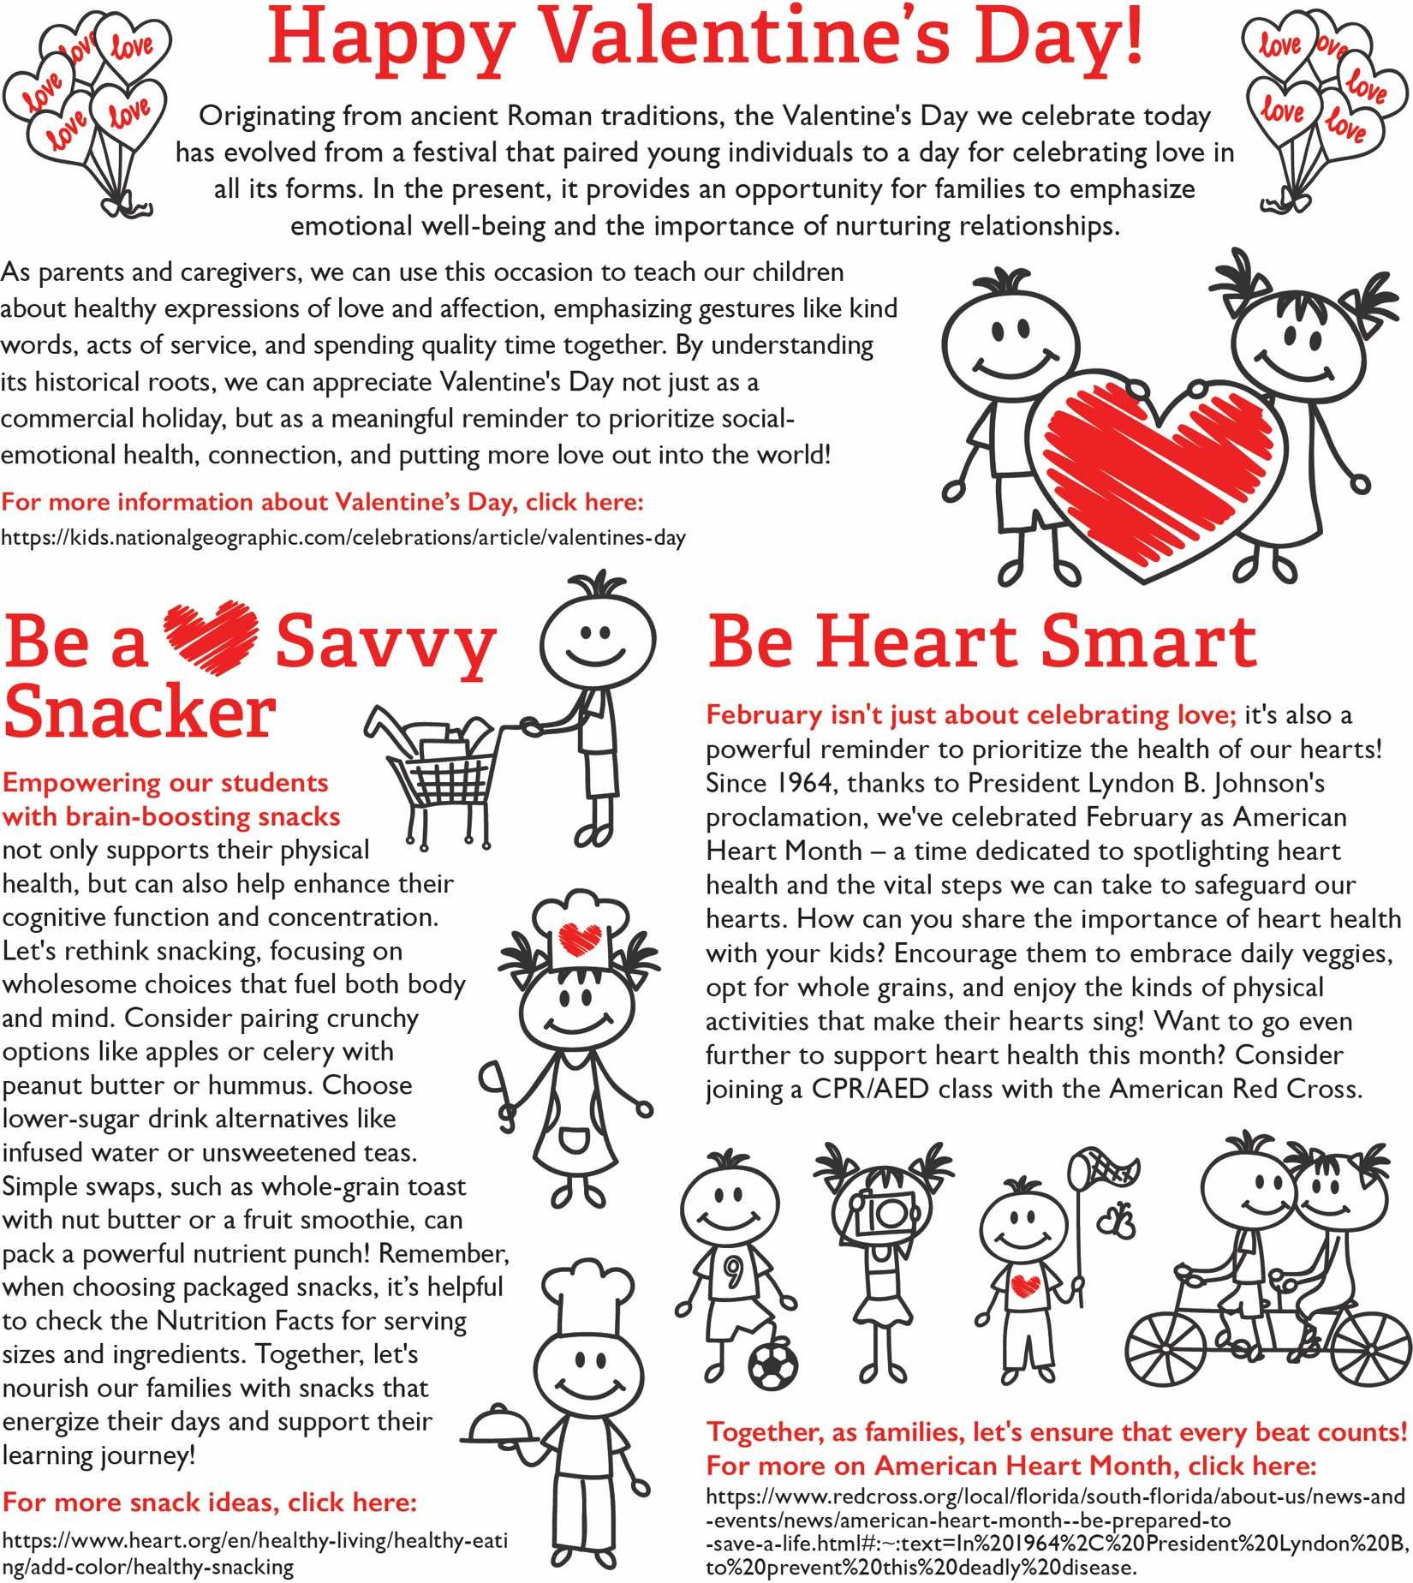

<https://rethinkschoolmeals.com/>

[https://www.redcross.org/local/florida/south-florida/about-us/news-and-events/news/american-heart-month--be-prepared-to-save-a-life.html - :~:text=In 1964, President Lyndon B,to prevent this deadly disease.](https://www.redcross.org/local/florida/south-florida/about-us/news-and-events/news/american-heart-month--be-prepared-to-save-a-life.html#:~:text=In%201964%2C%20President%20Lyndon%20B,to%20prevent%20this%20deadly%20disease.)