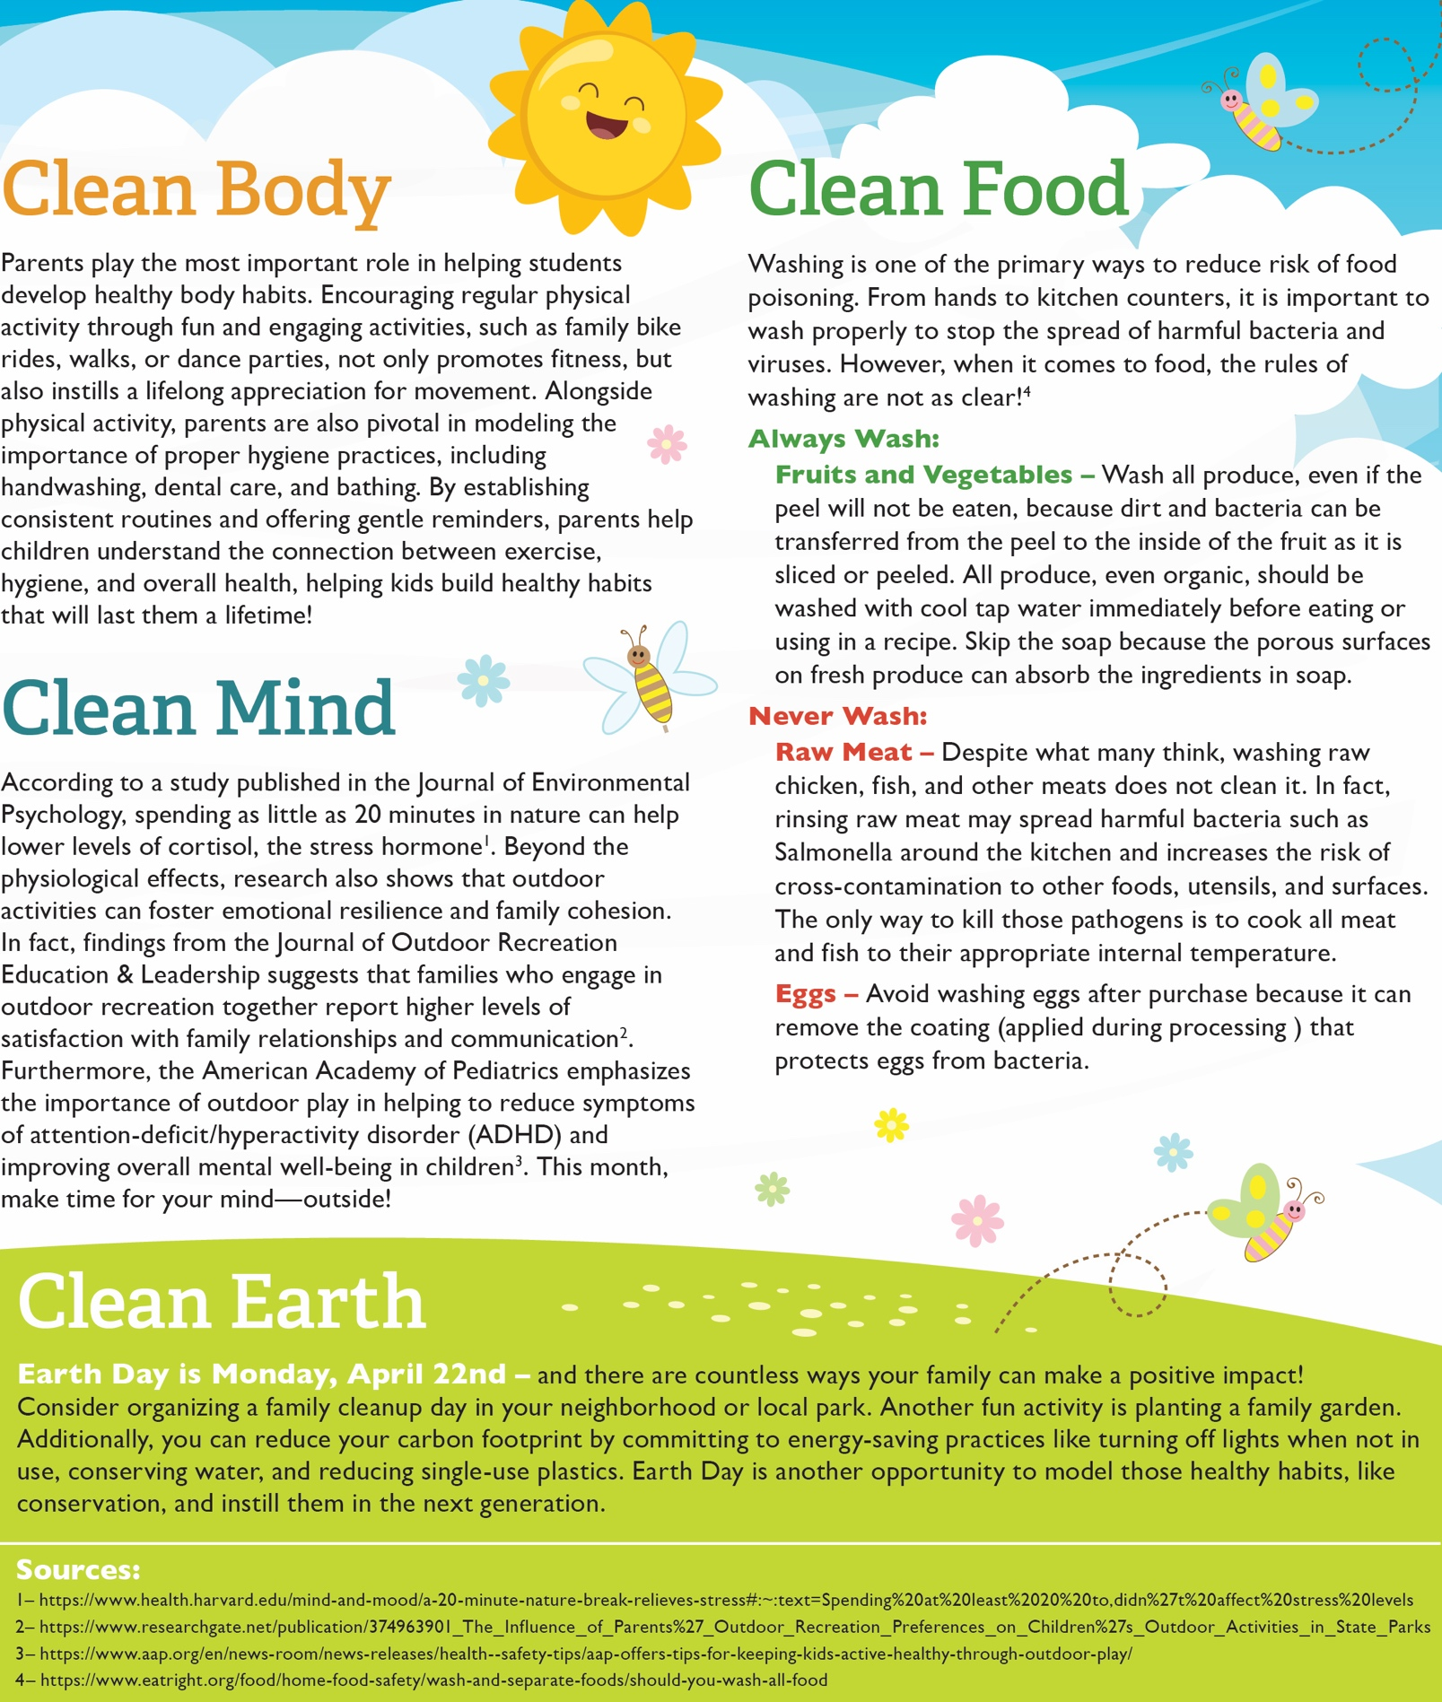

<https://www.eatright.org/food/home-food-safety/wash-and-separate-foods/should-you-wash-all-food>

<https://www.aap.org/en/news-room/news-releases/health--safety-tips/aap-offers-tips-for-keeping-kids-active-healthy-through-outdoor-play/>

<https://www.researchgate.net/publication/374963901_The_Influence_of_Parents%27_Outdoor_Recreation_Preferences_on_Children%27s_Outdoor_Activities_in_State_Parks>

[https://www.health.harvard.edu/mind-and-mood/a-20-minute-nature-break-relieves-stress - :~:text=Spending at least 20 to,didn%27t affect stress levels](https://www.health.harvard.edu/mind-and-mood/a-20-minute-nature-break-relieves-stress#:~:text=Spending%20at%20least%2020%20to,didn%27t%20affect%20stress%20levels)

<https://www.conagrafoodservice.com/>

<https://rethinkschoolmeals.com/>

<https://rethinkschoolmeals.com/>