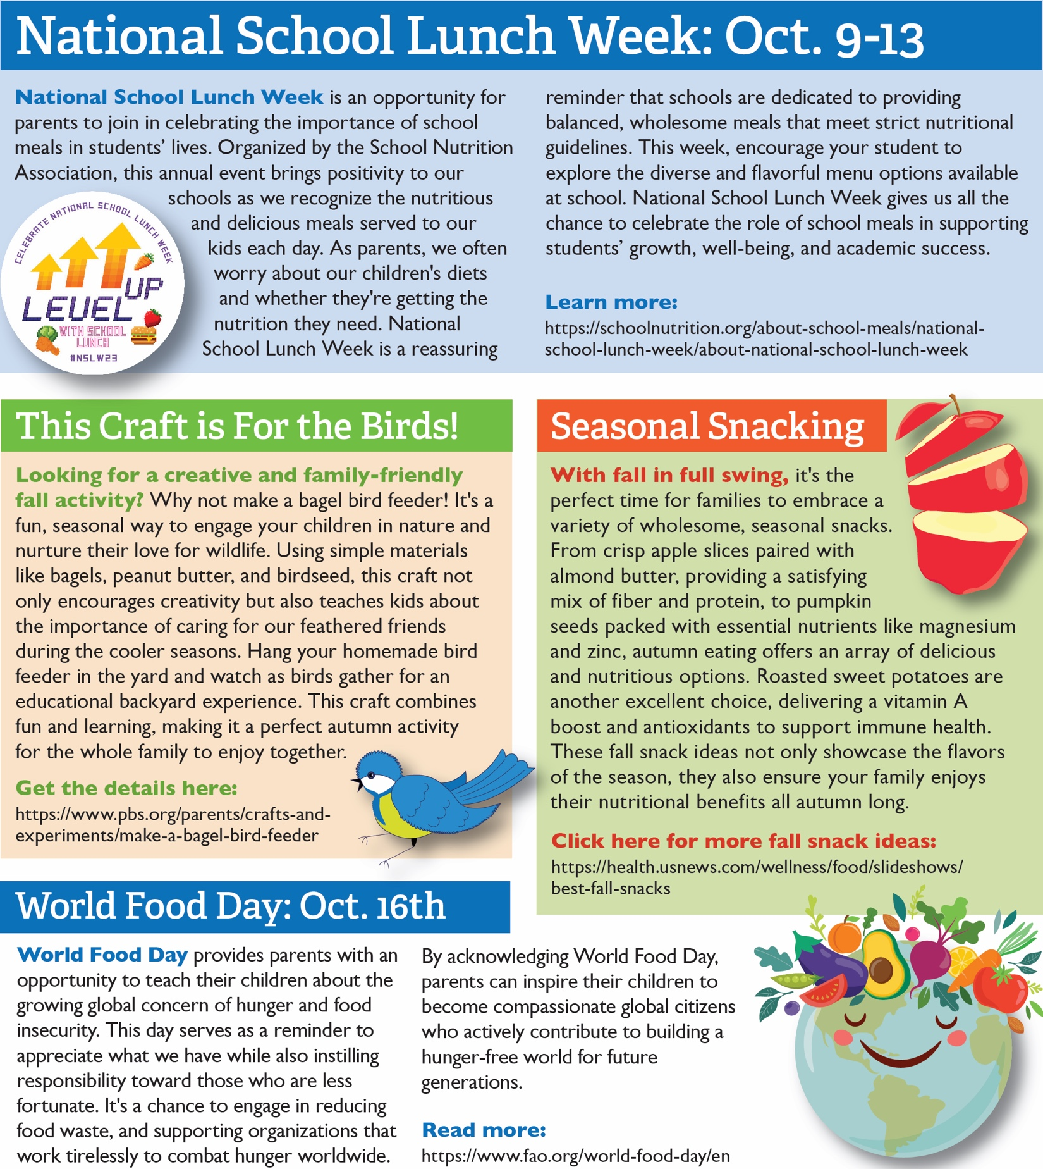

<https://www.fao.org/world-food-day/en>

<https://health.usnews.com/wellness/food/slideshows/best-fall-snacks>

<https://www.pbs.org/parents/crafts-and-experiments/make-a-bagel-bird-feeder>

<https://schoolnutrition.org/about-school-meals/national-school-lunch-week/about-national-school-lunch-week>

<https://www.feedingamerica.org/take-action/hunger-action-month>

<https://www.feedingamerica.org/take-action/hunger-action-month>

<https://www.myplate.gov/><https://www.mondaycampaigns.org/meatless-monday>

<https://www.myplate.gov/>