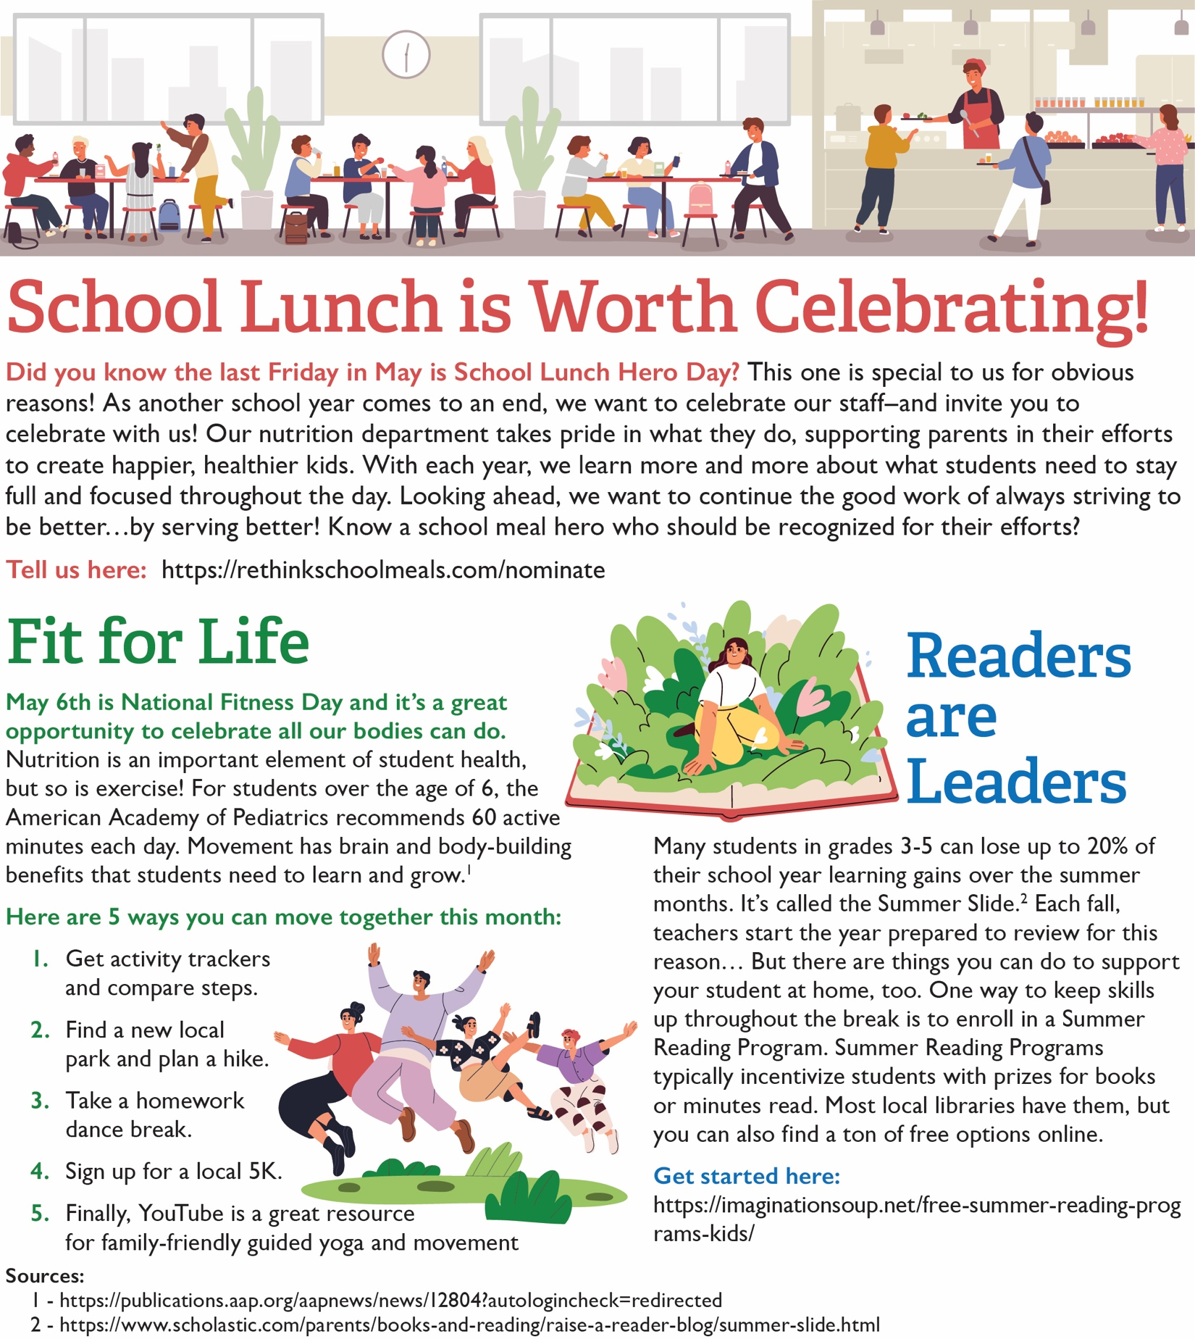

<https://www.scholastic.com/parents/books-and-reading/raise-a-reader-blog/summer-slide.html>

<https://publications.aap.org/aapnews/news/12804?autologincheck=redirected>

<https://rethinkschoolmeals.com/nominate>

<https://imaginationsoup.net/free-summer-reading-programs-kids/>

<https://www.myplate.gov/><https://www.mondaycampaigns.org/meatless-monday>

<https://www.myplate.gov/>

<https://www.myplate.gov/>