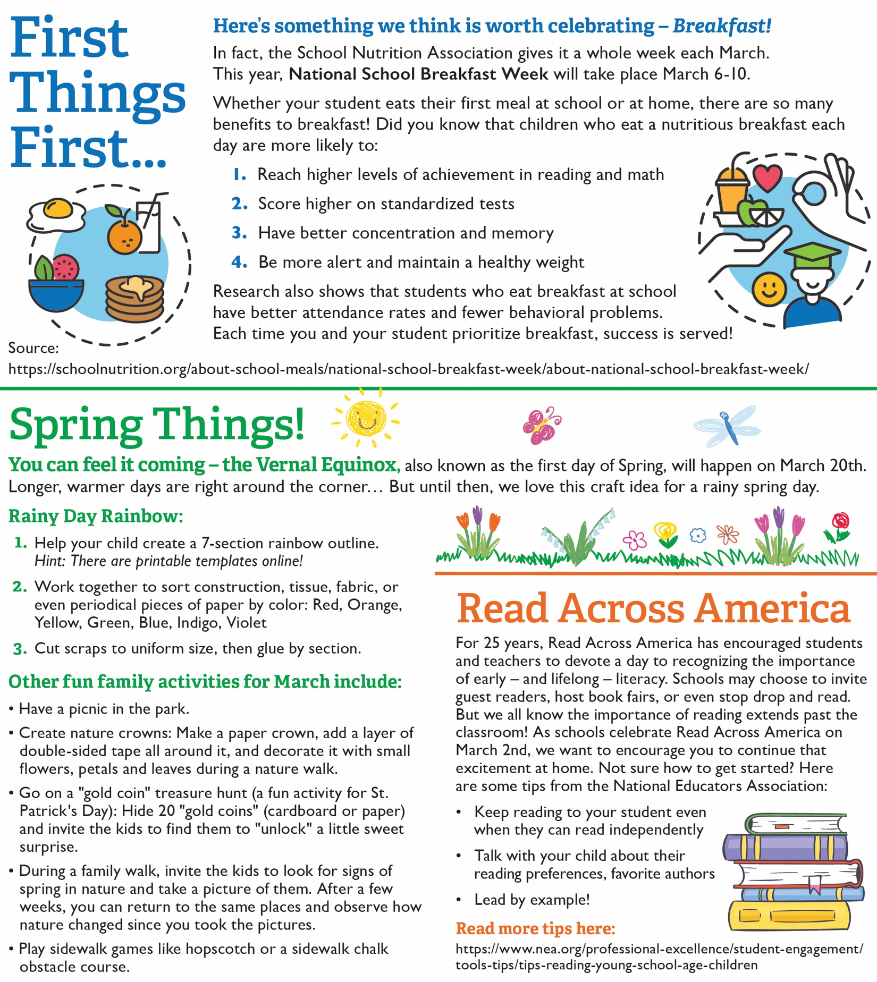

<https://www.nea.org/professional-excellence/student-engagement/tools-tips/tips-reading-young-school-age-children>

<https://schoolnutrition.org/about-school-meals/national-school-breakfast-week/about-national-school-breakfast-week/>