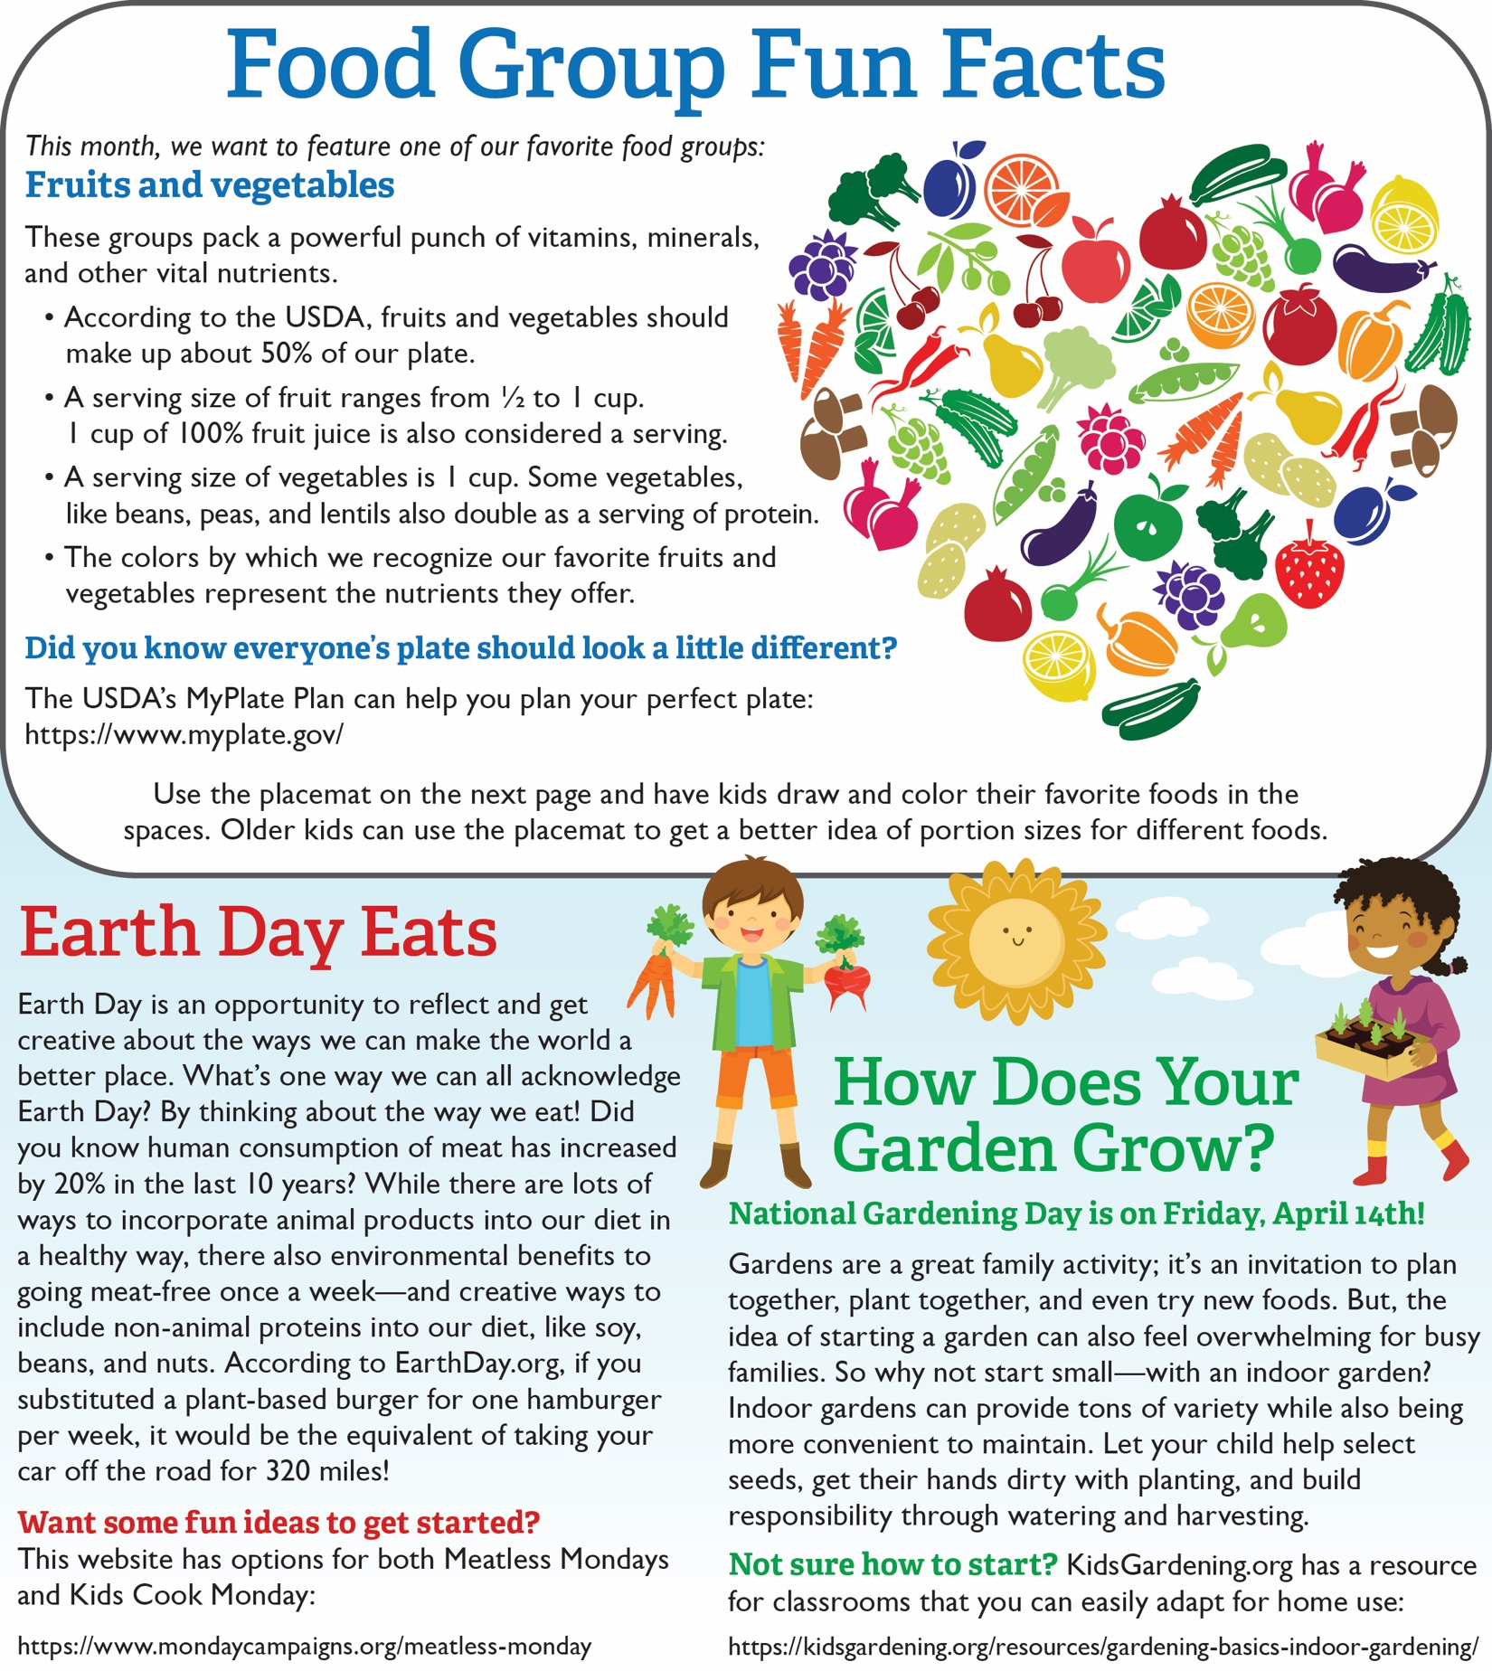

<https://www.myplate.gov/><https://www.mondaycampaigns.org/meatless-monday>

<https://www.myplate.gov/>

<https://www.myplate.gov/><https://www.mondaycampaigns.org/meatless-monday>

<https://www.myplate.gov/>

<https://www.myplate.gov/>

<https://www.myplate.gov/>

<https://www.myplate.gov/>