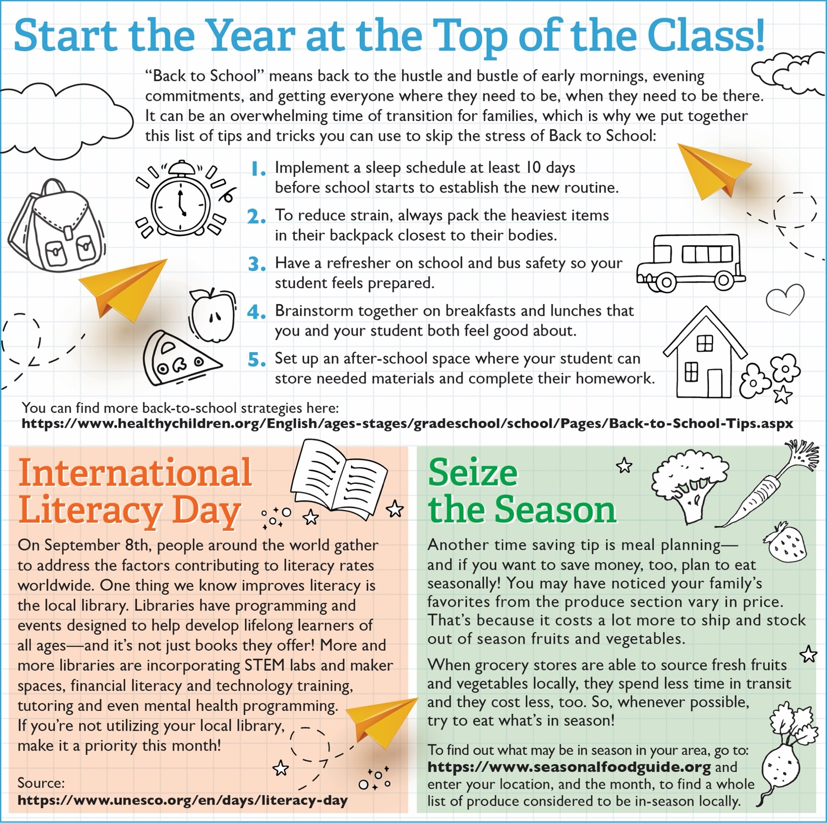

https://www.seasonalfoodguide.org/

https://www.unesco.org/en/days/literacy-day