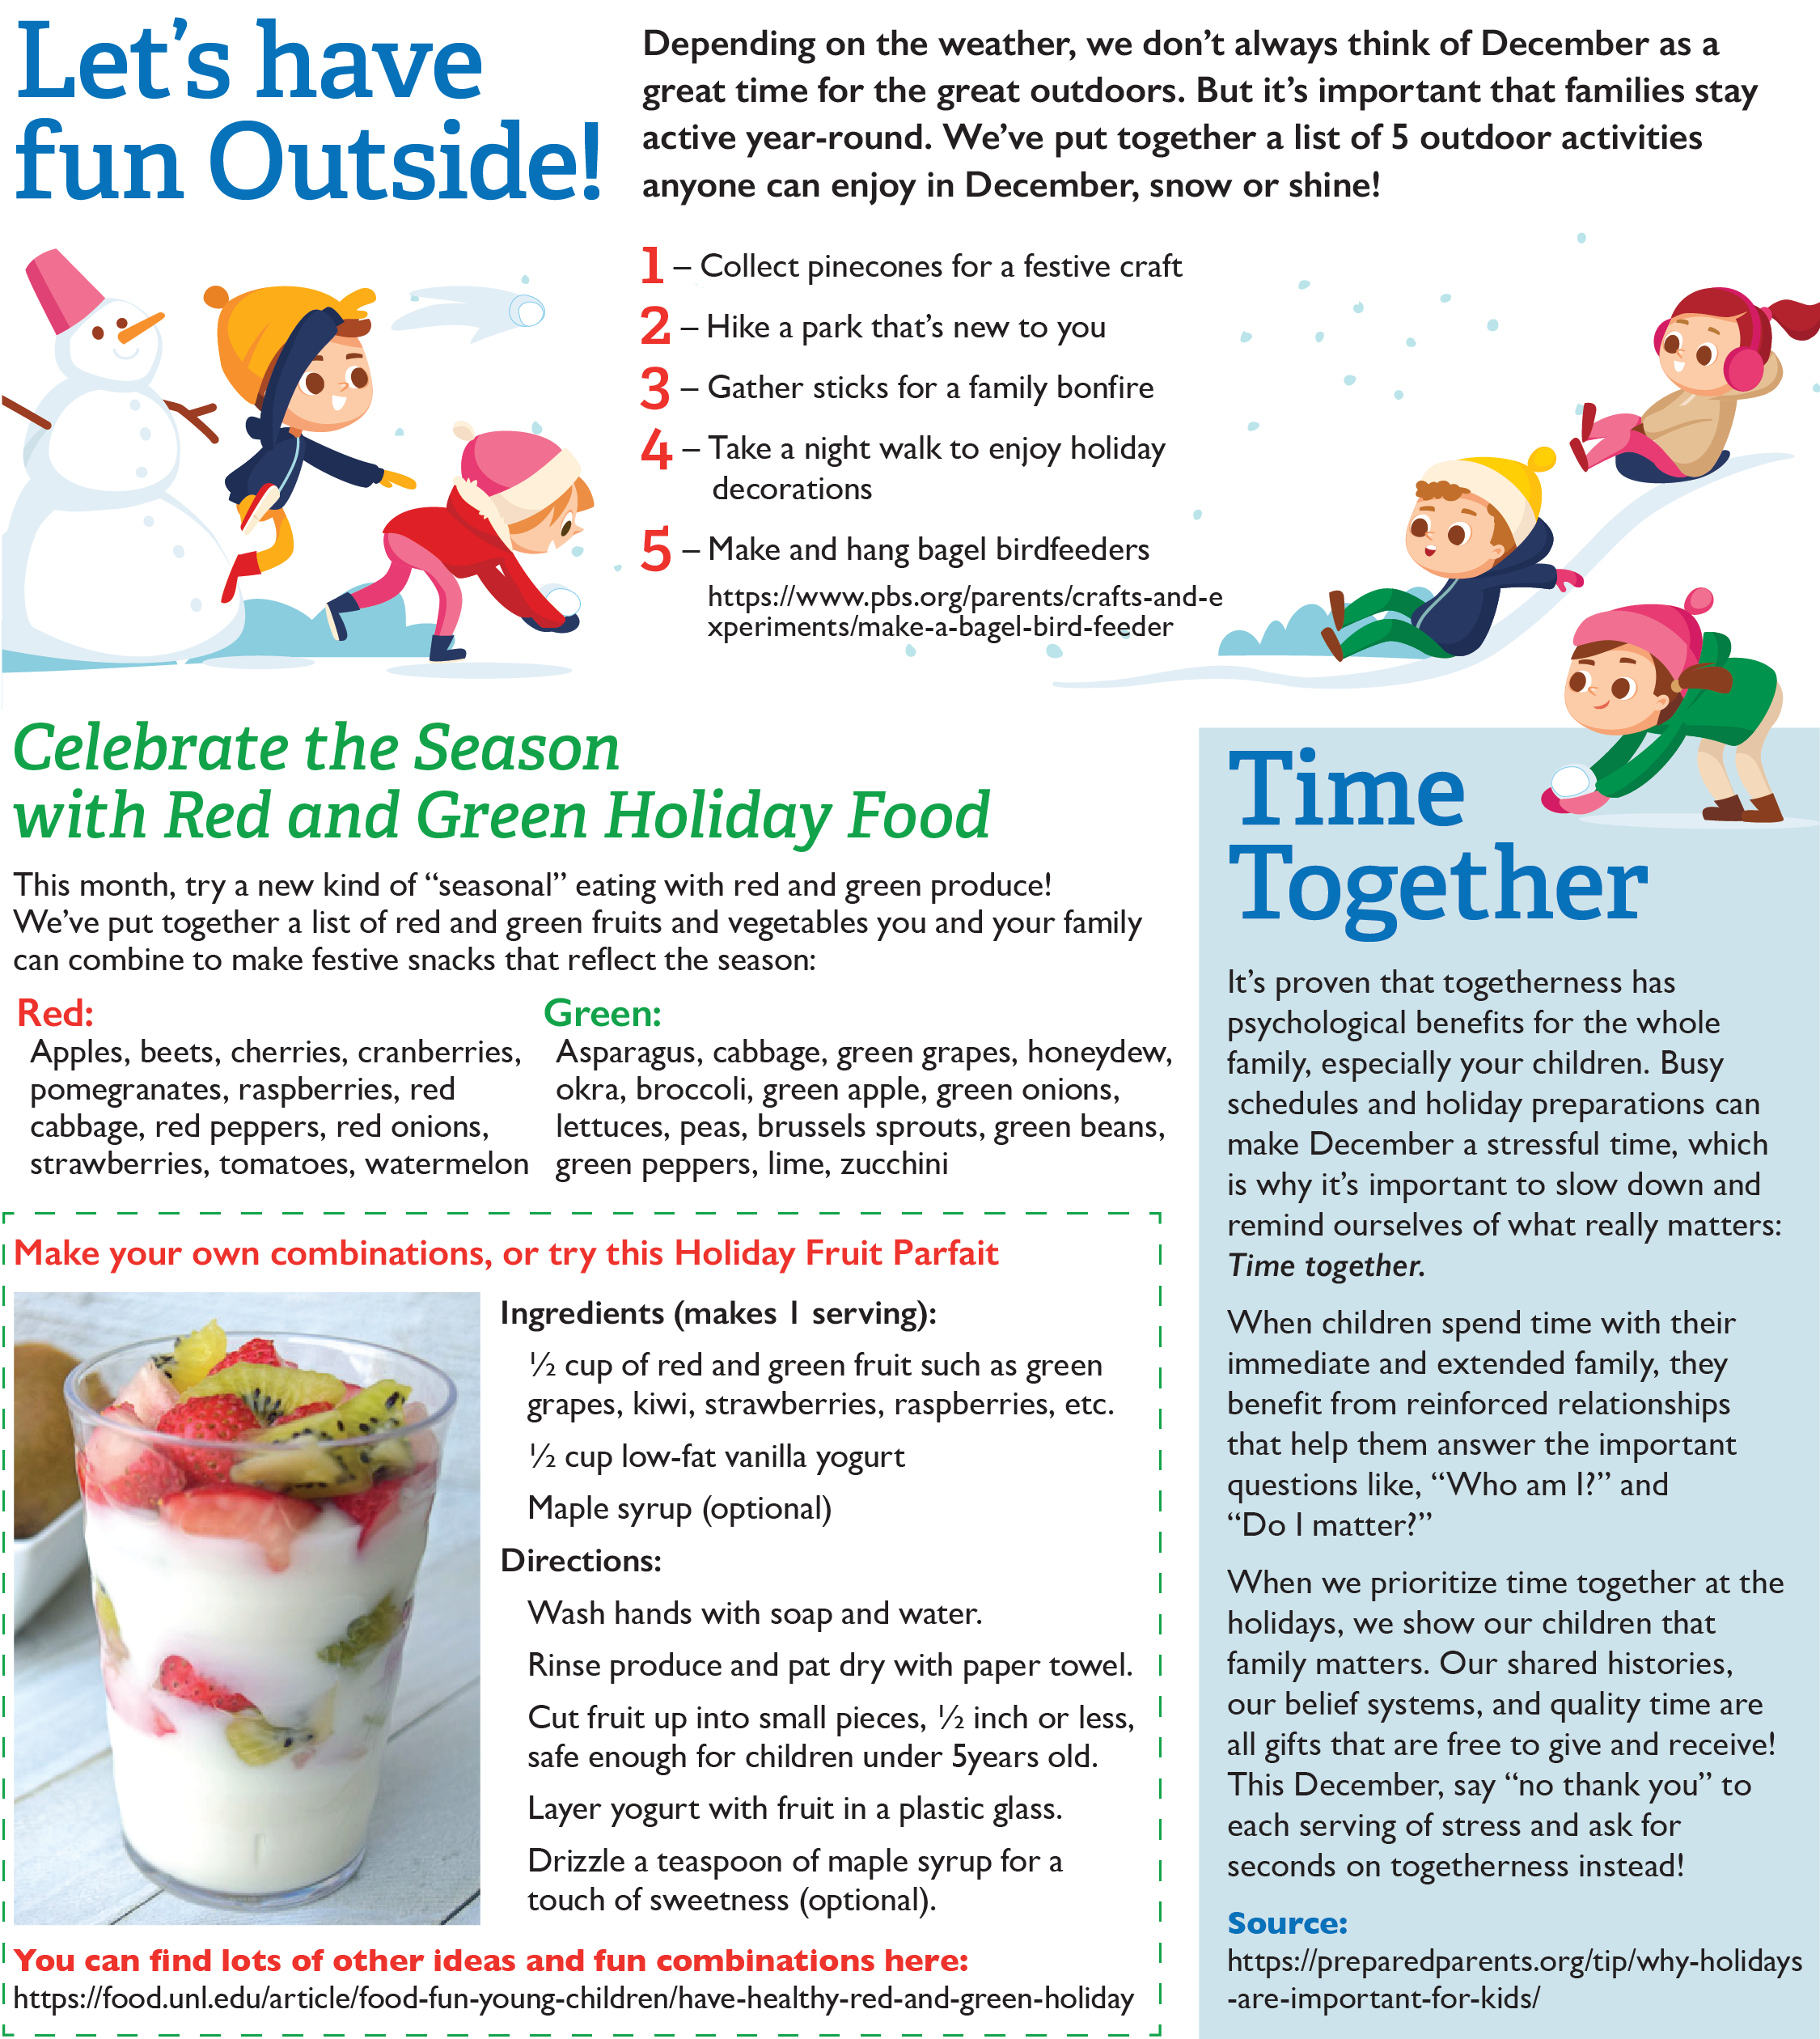



<https://food.unl.edu/article/food-fun-young-children/have-healthy-red-and-green-holiday>

<https://www.pbs.org/parents/crafts-and-experiments/make-a-bagel-bird-feeder>