*Logo Here.eps*

**JANUARY 2018**

18 Ways to Rethink Happy & Healthy in 2018

A New Year means new goals and we want to help you meet them! We found 18 health-related fun facts for you to share with your family. We hope they inspire you to make 2018 your happiest, healthiest year yet!

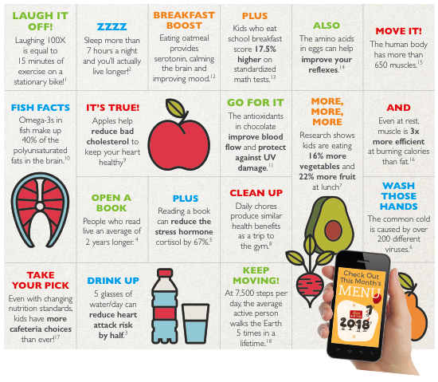

1. https://science.howstuffworks.com/life/inside-the-mind/emotions/laughter7.htm

2. http://www.nytimes.com/2002/02/15/us/study-ties-6-7-hours-of-sleep-to-longer-life.html

3. https://medical-center.lomalindahealth.org/patients-visitors/health-and-wellness/live-it/online-health-show/episode-7-water

4. http://www.sciencedirect.com/science/article/pii/S0277953616303689

5. http://www.telegraph.co.uk/news/health/news/5070874/Reading-can-help-reduce-stress.html

6. https://www.hopkinsmedicine.org/healthlibrary/conditions/pediatrics/upper_respiratory_infection_uri_or_common_cold_90,P02966

7. https://www.fns.usda.gov/pressrelease/2014/009814

8. https://www.newscientist.com/article/2148209-walking-to-work-or-doing-the-vacuuming-can-extend-your-life/

9. https://www.sciencedaily.com/releases/2011/04/110412131923.htm

10. https://www.ncbi.nlm.nih.gov/pubmed/15812120

11. https://www.ncbi.nlm.nih.gov/pmc/articles/PMC4696435/

12. https://www.livestrong.com/article/294169-foods-that-increase-serotonin-and-induce-sleep/

13. https://schoolnutrition.org/AboutSchoolMeals/MoreThanJustLunch/

14. https://www.sciencedaily.com/releases/2014/02/140211083859.htm

15. https://en.wikipedia.org/wiki/List_of_skeletal_muscles_of_the_human_body

16. https://www.livestrong.com/article/256919-how-many-calories-does-muscle-burn-compared-to-fat/

17. www.pewtrusts.org/en/research-and-analysis/2016/7/19/five-facts-about-school-meal-programs

18. https://snowbrains.com/brain-post-how-far-does-the-average-human-walk-in-a-lifetime