Our New Favorite Color!

It’s February, which means you’re already seeing a little red, right? Well, we want to encourage you to see even more—and you can start with the foods you serve at home!

**You’ve probably heard that it’s best to eat a rainbow of   
colors, right?** Well, that’s because each color tends to represent certain nutrients your body needs.

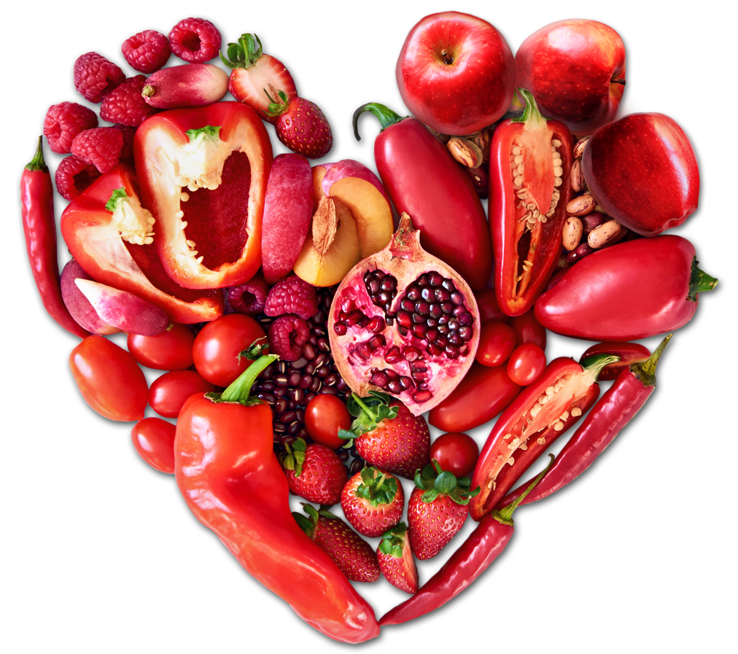**Red fruits and vegetables are antioxidant-packing powerhouses**, which means they actually protect the cells in your body from damage. Ripe raspberries and red peppers are just two tasty ways   
to show your cells some love!

**Feeling “chili”?   
Red beans are a versatile way to add color, fiber, and protein to your meal.** Pair red beans with tomatoes and lean protein, and you’ve got a warm winter meal packed with antioxidant power!

**Speaking of tomatoes,** the base of our popular pizzas is a 51% whole grain crust topped with fresh-tasting tomato sauce! We finish it with low fat mozzarella cheese and reduced fat pepperoni… But that snappy red sauce is just one more way we make sure your student is eating their colors, every day!

****Make Your Move**

Did you know the current recommendation is that children get at least **60 minutes of physical activity each day?** That means regardless of the weather, we all have to keep moving! Here are some ways to get up and go, even indoors:

*Search for yoga exercises online and see who can hold their pose longest!*

*Sledding burns over 400 calories in just one hour!*

*Consider offering incentives for outside chores like shoveling...*

