*Logo Here.eps*

**MAY 2017**

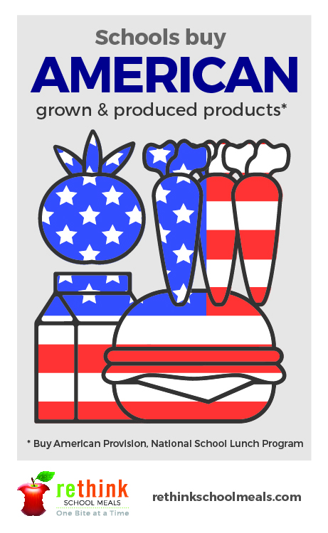Thank you, parents!

As another school year comes to an end, we want to extend our warmest thanks. Our nutrition department takes pride in what they do, supporting parents in their efforts to create happier, healthier kids. With each year, we learn more and more about what students need to stay full and focused throughout the day. Looking ahead, we want to continue the good work of always striving to be better… by serving better! Know a school meal hero who should be recognized for their efforts? Tell us here: https://rethinkschoolmeals.com/nominate

Farm-to-School pride

What makes you proud to be an American? Everyone’s answer is likely a   
little different, but here’s one of ours: whenever we can, we look local first. Because we know that by looking local, we can find the best available produce, dairy, meats, and grains—grown and produced right here in our region. Sourcing local is a patriotic choice, because it helps to support American farmers working right where we live. So whenever you can, look local!

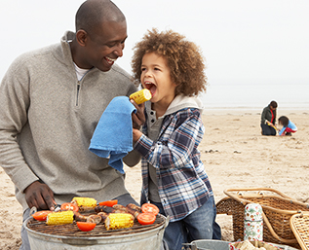Barbeque basics

Nothing says summer quite like a cookout! Plus, grilling is a healthy alternative to fatty options like frying. This summer, try making the most of your family cookout with these quick tips:

* Try grilling mushrooms, peppers, squash, corn and other veggies brushed with oil for a healthier side dish
* Marinate meats, chicken or fish before grilling
* Start with a salad of dark salad greens topped with low fat dressing

shutterstock_287238812_screened_1.tif

We’re rethinking school meals!

Join us as we celebrate the good   
work in schools across the country.

**www.rethinkschoolmeals.com**