*Logo Here.eps*

**MARCH 2017**

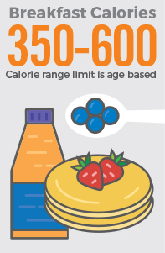With any luck…

Your day started with a breakfast that was as delicious as it was nutritious.   
If not, we’ll share our magic formula: starting with the right combination of whole grains and proteins is what you need to power through your day. Here’s our breakfast breakdown:

* We use at least 51% whole grains
* Lean proteins provide energy without the fat
* And we make sure to include fruits and vegetables wherever we can,   
  up to 5 cups each week!

One size does NOT fit all.

Everyone needs to eat breakfast, but exactly how much depends on several factors: age, gender, weight, and height all play a part. Because the food we serve goes to growing kids, we make sure the meal matches the caloric needs of the child. Our youngest students receive approximately 350 calories at breakfast, up to 600 calories for our oldest.

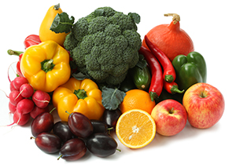Good as gold!

The pot of gold is at the end of what? A rainbow! And a rainbow is exactly what each meal we eat should look like—with breakfast being no exception! Getting fruits and veggies into the morning routine can be tough, but here are some time saving tricks:

* Buy pre-chopped vegetables to include in eggs or hash
* Look for frozen fruit blends that are smoothie-ready
* Stick to flavors you know they already like so everyone starts the day with a smile!

shutterstock_287238812_screened_1.tif

We’re rethinking school meals!

Join us as we celebrate the good   
work in schools across the country.

**www.rethinkschoolmeals.com**