*Logo Here.eps*

**JANUARY 2017**

Hearty and Healthy

As the cold days of winter continue, our nutrition staff is here—serving up school meals that are warm and welcoming! Each morning, our team is hard at work preparing for your child’s meal times. This month’s menu is full of familiar favorites that we’re sure they’ll love. This winter, consider letting us do the cooking…   
we promise to serve their meal with a smile that’s just as warm!

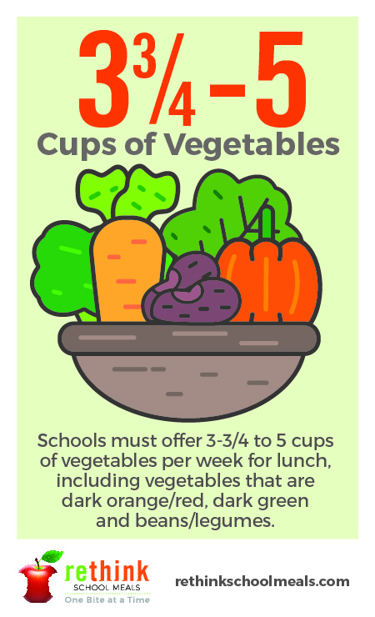Your Resolution Solution

This time of year, most people resolve to “get healthy”—but did you know that resolving to save money is almost as popular? And we have good news if either or both of those resolutions are on your family’s list... the meals we serve are comprised of at least 51% whole grains and reduced fat dairy to support a healthy body weight; plus we offer up to 5 cups of fruit **and** 5 cups of vegetables each week.\* So not only are school meals health-conscious, they’re also cost-conscious—saving families an average of $.25 per day!\*\*

Snack on This!

The time between school and dinner tends to be the busiest, right? And of course, it’s a time most students want a snack! Here are some tips:

* Prep fruits and veggies on Sunday so they’re ready to serve.
* Splurge a little on fresh but pre-packaged snacks like cheese sticks and individual serving sizes of hummus and peanut butter.
* Make “pantry mix” together… Collect leftover nuts, cereals, and maybe even a couple chocolate chips to create your very own trail mix!

\*According to USDA National School Lunch Program guidelines \*\*Based on average meal prices for the 2014-15 school year

shutterstock_287238812_screened_1.tif

We’re rethinking school meals!

Join us as we celebrate the good   
work in schools across the country.

**www.rethinkschoolmeals.com**