*Logo Here.eps*

**FEBRUARY 2017**

So Much to Love

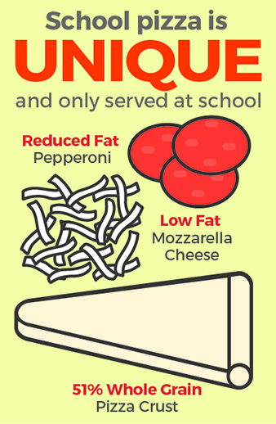We put a whole lot of love into our menus. We start with at least 51% whole grains, incorporate fresh and colorful fruits and vegetables, with reduced fat dairy, and **never** any trans fats. We even source food locally when we can! Altogether, these quality ingredients make for quality meals—and we know that’s important to you. During the cold winter months, let us do the cooking—we’ll be serving up warm meals they’ll love, right from the heart!

Tomatoes are red, school meals are cool…

**…We love our pizza, and we know they do, too!**

We make everyone’s favorite food a nutritious option. Our pizza starts   
with a 51% whole grain crust, then we top it with real ingredients—zesty tomato sauce, low fat mozzarella cheese, and reduced fat pepperoni.   
The result? Well, it’s amoré!

Make Your Move

When the temperatures drop, it’s hard to   
keep activity levels up… but did you know   
the current recommendation is that children   
get **at least** 60 minutes of physical activity each day? That means regardless   
of the weather, we all have to keep moving! Here are some ways to get up and   
go, even indoors:

* Search for yoga exercises online and see who can hold their pose longest!
* Sledding burns over 400 calories in just one hour!
* Consider offering incentives for outside chores like shoveling…   
  maybe they could pick dinner and a movie for the family this weekend?

shutterstock_287238812_screened_1.tif

We’re rethinking school meals!

Join us as we celebrate the good   
work in schools across the country.

**www.rethinkschoolmeals.com**