*Logo Here.eps*

**APRIL 2017**

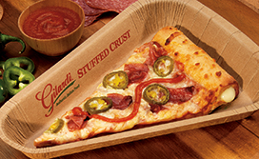Pizza, please!

**Everyone** loves pizza… and the pizza we serve has even more to love about it. Like every meal we prepare, our pizza is made with your child in mind. And, it can only be found through school meal programs. What makes it so special? Well, we start with a 51% whole grain crust and flavorful tomato sauce. Finally, we top our pizza with reduced fat cheese and lean meats. Of course, all of   
our ingredients are USDA inspected and fit within current nutrition recommendations. The final product? A pizza that’s perfecto!

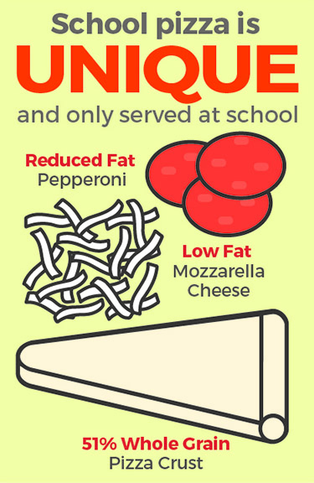Why whole grains?

Well, because whole grains are more wholesome! They actually offer more nutrition than their more simple counterparts. White bread digests more easily, giving a quick burst of energy; whole grains are digested more slowly, giving our bodies more consistent energy throughout the day. And that’s why we start our pizza process with a 51% whole grain crust—so our pizza can help your student power through!

Swap-ortunities

Think your family could benefit from a grain change? Our recommendation is to start small. Choose a favorite meal you make at home—like pizza!—and keep everything the same except the grain. Buy a whole grain crust instead and see how you like it! Here are a few other swap-ortunities:

* Look for noodles with higher fiber content
* Instead of instant oatmeal, try rolled oats
* Try 1 whole grain tortilla for your sandwiches, rather than 2 slices of bread!

shutterstock_287238812_screened_1.tif

We’re rethinking school meals!

Join us as we celebrate the good   
work in schools across the country.

**www.rethinkschoolmeals.com**