*Logo Here.eps*

**NOVEMBER 2017**

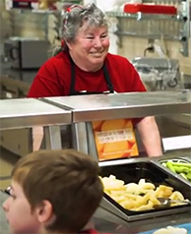Something to be Thankful For

This is the time of year we think about giving thanks... and for us it’s the opportunity to nourish your child each week! We know you put a lot of trust into our nutrition staff, and we take that seriously. Our team works together to craft a menu that appeals to both students and their parents. Time, talent, and a lot of love go into every meal we serve your child! Together, we’re building healthier bodies and brains... thanks for letting us help!

School Meal Heroes

We think of our nutrition department as heroes. Their work is important—feeding our students balanced meals to nourish their bodies while   
boosting their brainpower. But that work often goes unnoticed. Have you   
or your student had a positive experience with one of our school nutrition professionals you would like to share? We want to hear about it! You can nominate a School Meal Hero online at rethinkschoolmeals.com/nominate.

Happy Harvest!

The traditional Thanksgiving meal can teach us a lot about how we should be eating—with lean protein at the center, surrounded by colorful, nutritious sides, shared together with family. If only every meal could be like that! But with busy family schedules, focused meals can be a challenge... so, let’s all take some tips from Thanksgiving. In the coming months, try to stretch out the celebration by serving healthier food and taking more time to be together!

   
  
We’re rethinking school meals!

Join us as we celebrate the good   
work in schools across the country.

**www.rethinkschoolmeals.com**