*Logo Here.eps*

**DECEMBER 2017**

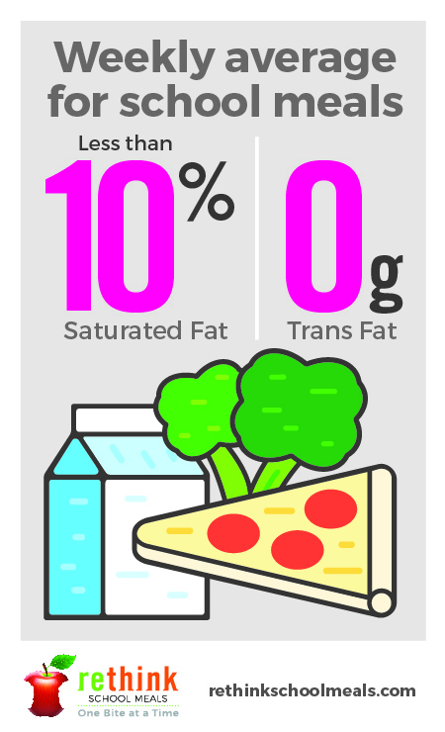Here’s to a HEALTHY New Year!

We want to share our resolution with you... along with a happy holiday, we also want to have a *healthier* new year. All across the country, people are coming together to rethink what school meals should be. Today, we’re serving more delicious and nutritious meals—with at least 51% whole grains, featuring lean meats, reduced-fat dairy, and more fruits and vegetables than ever before! We hope you’ll agree that is something to really celebrate!

A Fact Check on Fats

We hear all the time that fats are bad—but that’s not necessarily true! Studies show that incorporating a mix of good fats into your diet actually helps maintain a healthier body weight **and** boosts brainpower! Healthy fats you can incorporate in your home cooking include oils like olive and coconut, avocado, and Omega-3s from fish and flax. And we keep bad fats in check in school meals—serving less than 10% in saturated fats and never trans fats.

Healthy Starts with Happy!

Holiday meals are often a time we splurge, but a couple small changes could keep everyone happier and healthier this season:

Before you start cooking, put some pep in your step with a family walk or run.

Start with a healthy appetizer like fresh fruits and vegetables.

Enlist some helping hands... get the kids involved! This could be prepping vegetables or making desserts.

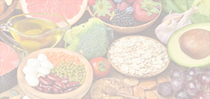

We’re rethinking school meals!

Join us as we celebrate the good   
work in schools across the country.

**rethinkschoolmeals.com**