*Logo Here.eps*

**OCTOBER 2016**

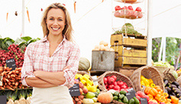Looking Local

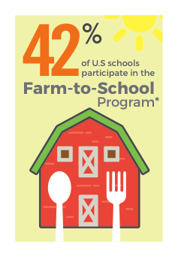When we plan our school meal menus, we look local whenever possible. You may have heard of “Farm-to-Table,” which means sourcing the freshest ingredients from local farms. Well, we like to call it “Farm-to-School.” By looking local, we’re able to offer students the highest quality fruits and vegetables, grains, protein, and dairy, while also helping to sustain our local farming economies. The result is colorful meals that are farm-fresh!

A Trend on the GROW

Today, more than **42% of U.S. schools**\* are participating in a Farm-to-School program. The benefits of Farm-to-School activities like these are far-reaching and   
the statistics show that Farm-to-School is a trend that is here to stay.

• Farm-to-School reaches **23.6 million students\*** nationwide

• A total of **42,587 schools\*** in 50 states participate in Farm-to-School activities

• Participating schools have purchased **$789 million\*** worth of local food

• **2,000 schools surveyed\*** plan to start Farm-to-School activities in the future

Locally sourced food might not be what most people imagine is at the core of   
a school meal program, but we’re all working together to rethink what school   
meals could (and should) be!

You’re Invited!

Farm-to-School exists because schools and their suppliers are listening to parents like you! As this trend continues to grow in schools across the country, there are opportunities for parents to speak up. Contact your school nutritionist to learn more about the Farm-to-School program and see how you can help. When everyone comes to the table with their best ideas, students benefit!

\* Estimated based on data from the USDA Farm to School Census for the 2013-2014 school year. *Source: farmtoschool.org*

shutterstock_287238812_screened_1.tif

We’re rethinking school meals!

Join us as we celebrate the good   
work in schools across the country.

**www.rethinkschoolmeals.com**