*Logo Here.eps*

**MAY 2016**

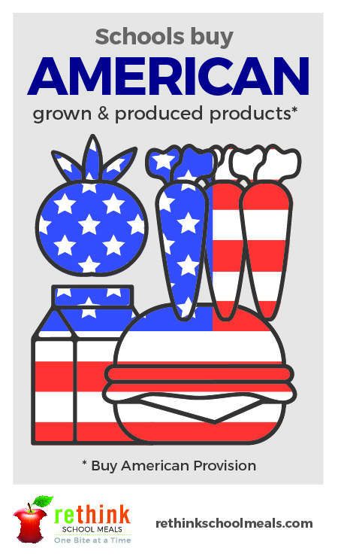Thank You!

As we approach the end of the school year, we want to thank you for letting us be a part of your student’s school day! Parents have a big job to do, providing delicious and nutritious meals to their children—and we’re honored to have joined you in that endeavor this year. Looking ahead, we’re committed to continuing the good work that’s happening in school meal programs all across the country next school year.

Schools Buy American

Memorial Day is a time when we remember the sacrifices of the men and women who have served in our armed forces and honor them by displaying pride in our country. Schools source locally grown and domestically produced ingredients for their cafeterias as much as possible. By looking local first, we help to bolster our local economy. And when you provide your student with a school meal, you’re doing the same thing! The most recent USDA Farm to School Census shows that schools invest $790 million dollars in their local communities through their nutrition programs!

Summer Boot Camp

Did you know our military is rethinking the meals they serve as well? They are moving away from fried sides toward healthier fruit and vegetable options. Our soldiers are an example of the fitness/food balance we should all strive for. Together, let’s follow their lead this summer—staying active and making the most of our meal choices!



shutterstock_287238812_screened_1.tif

We’re rethinking school meals!

Join us as we celebrate the good   
work in schools across the country.

[**www.rethinkschoolmeals.com**](http://www.rethinkschoolmeals.com)