*Logo Here.eps*

**MARCH 2016**

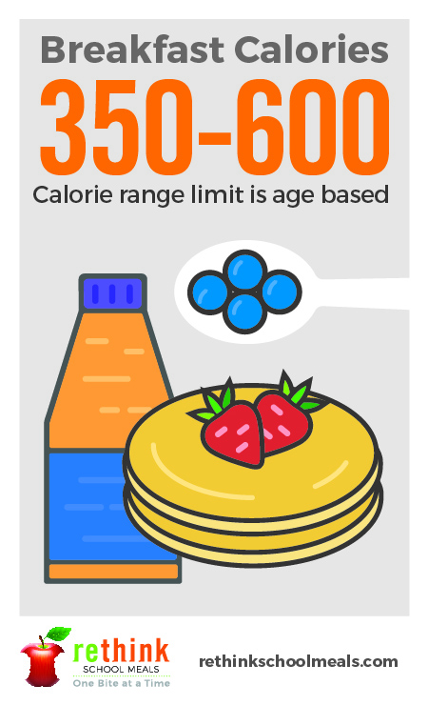Need help starting the day? You’re in luck!

A good day starts with a good attitude…and a **nutritious** meal! Studies show that when students begin the day with a balanced breakfast, they are ready to succeed in the classroom. Making the most important meal of the day count can be challenging, but our school nutritionists are up early to make sure your kids   
get a great start to the day. Here are some of our secrets to breakfast success:

• We serve at least 51% whole grains.

• We offer low- and non-fat dairy for protein.

• And we incorporate fruits and vegetables, up to 5 cups per week!

The right amount at the right time…

So we know breakfast is important, but how much is too much (or too little?)   
We base the calorie recommendations for all the meals we serve on age.   
Younger students receive up to 350 calories and older students up to 600.

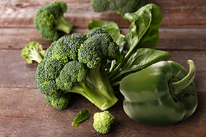Get in some green!

Shamrocks might be green, but spinach makes a better choice for an omelet! And there are other ways to incorporate vegetables into your morning meal, too. Broccoli and peppers can be pre-chopped, frozen, and also cooked in eggs. Another place to pump up the produce is smoothies: kale blends and pairs well with strawberries or pineapple!



shutterstock_287238812_screened_1.tif

We’re rethinking school meals!

Join us as we celebrate the good   
work in schools across the country.

[**www.rethinkschoolmeals.com**](http://www.rethinkschoolmeals.com)