*Logo Here.eps*

**JANUARY 2016**

Warm Hearts, Warm Meals

Kids Small.tifEach morning we have the students in mind as we prepare meals that are as delicious as they are nutritious! And with winter settling in, we know how much they appreciate a warm meal at lunchtime. Sandwiches are always a good option, but at this time of year, sometimes a heartier meal from a happy face is just what they need! Let us make their meals this month… We promise to serve it up with a smile!

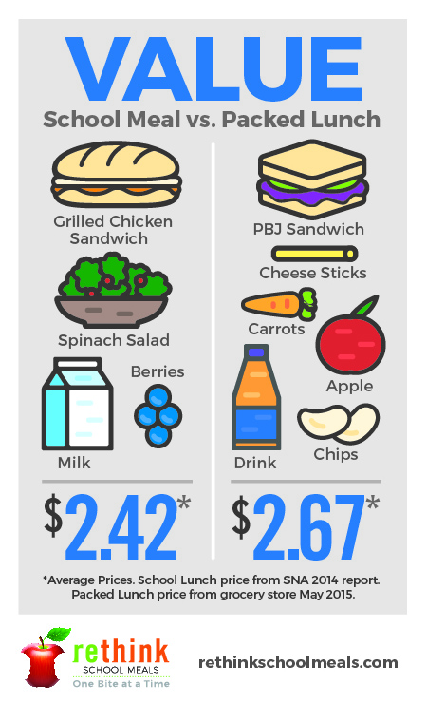Resolve to Spend Less

According to polls, saving money is almost as popular a New Years Resolution as getting healthy! If your family resolved to improve in one or both of those areas, our school nutrition staff is here to help. The meals we serve are comprised of at least 51% whole grains and reduced fat dairy to support a healthy body weight; plus we offer up to 5 cups of fruit and 5 cups of vegetables each week. But the best part? Providing your child with a school meal rather than packing a lunch **saves an average of $.25 per day**!

Oh What Fun!

Kids are more likely to make a healthy food choice when we make it fun! This month, surprise them with a special after school snack:

* Mix their favorite fruits with some new or exotic options on a skewer.
* Set up a veggie tray with reduced fat ranch or hummus.
* Make “pantry mix” together… Collect leftover nuts, cereals, and maybe even a couple chocolate chips to create your very own trail mix!

shutterstock_287238812_screened_1.tif

We’re rethinking school meals!

Join us as we celebrate the good   
work in schools across the country.

[**www.rethinkschoolmeals.com**](http://www.rethinkschoolmeals.com)