*Logo Here.eps*

**February 2016**

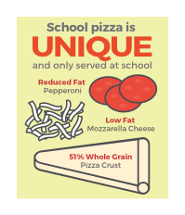Fall in Love with…School Meals!

You put a lot of love into the meals you make your child—and so do we! Each day, starting with breakfast, we’re getting ready in the kitchen with your student in mind…knowing they have a big day ahead and that we’re part of it. The meals we serve are delicious **and** nutritious; and there’s a whole lot to love about them! We use fresh and even local ingredients, at least 51% whole grains, reduced fat dairy, and never any trans fats. Plus, school meals cost $.25 less than the average packed lunch. All together, school meals are a winning choice that parents **and** students can fall in love with!

“Piece” of Mind

What happens when you make their favorite food a healthy option? Pizza Day! Our pizza starts with a 51% whole grain crust, then we top it with flavorful ingredients—zesty tomato sauce, low fat mozzarella cheese, and reduced fat pepperoni. The result is light on fat but FULL of flavor...Bravo!

Keep Active, Keep Healthy

Keeping active is key to keeping healthy…and keeping parents sane during the long winter months! The current recommendation is that children get **at least** 60 minutes of physical activity each day. Here are some ideas to get moving this month:

* Look for local gyms that offer student or family rate discounts.
* Visit your library and let your child select a fitness video to rent.
* 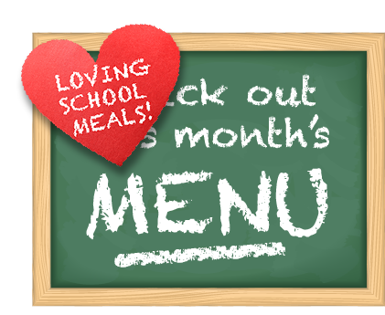Twister, hide and seek, or even a dance off can get the whole family moving—and laughing—together!



We’re rethinking school meals!

Join us as we celebrate the good   
work in schools across the country.

[**www.rethinkschoolmeals.com**](http://www.rethinkschoolmeals.com)