*Logo Here.eps*

**DECEMBER 2016**

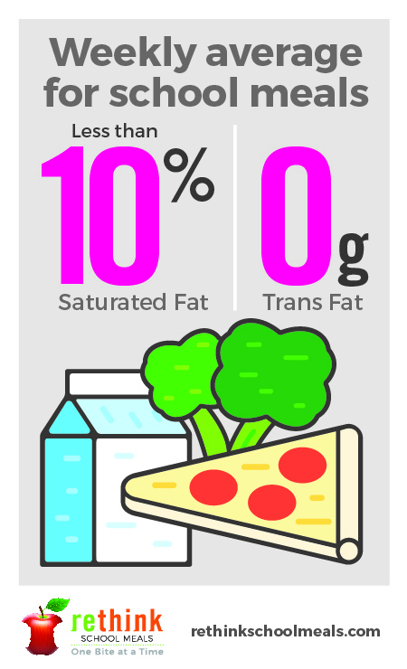And a Healthy New Year!

We want to share our resolution with you… along with a happy holiday, we also want to have a *healthier* new year. We’ve been part of a movement all across the country to rethink what school meals should be. Today, we’re serving more delicious and nutritious meals—with at least 51% whole grains, featuring lean meats, reduced-fat dairy, and more fruits and vegetables than ever before! We hope you’ll agree, that’s something to really celebrate!

Just the Facts

We hear all the time that fats are bad—but that’s not necessarily true!   
Among other benefits, healthy fats are tied to feelings of fullness **and** brain development. The trick is getting the right kinds of fats into your diet. We look   
for opportunities to incorporate healthy fats—which you can, too! Healthy   
fats include oils like olive and coconut, avocado, and Omega-3s from fish   
and flax. When you get the right balance of fats, you actually feel better!

A Happier Holiday

A holiday meal with friends and family can feel like a marathon, especially if you’re the one cooking! Here are a couple quick tips to keep everyone’s energy up:

* + - * + Enlist some helping hands… get the kids involved! This could be prepping vegetables or making desserts.
        + Take a break… the holidays aren’t all about food; they’re about togetherness. So plan on some quality time with family.
        + Incorporate some activity… take a long family walk or start a living room dance party!

shutterstock_287238812_screened_1.tif

We’re rethinking school meals!

Join us as we celebrate the good   
work in schools across the country.

**www.rethinkschoolmeals.com**