*Logo Here.eps*

**APRIL 2016**

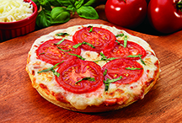We make the most out of “Pizza Day”…

And by “the most,” we mean the most delicious **and** nutritious. Did you know the pizza we serve is only available through schools? So while it tastes as good as what you get from the local pizzeria, it’s also good for you. We start with a 51% whole grain crust, then we top that with reduced fat cheese and lean meats. School nutritionists can also customize pizzas with fresh veggies and herbs for unique, healthy lunch offerings. All of our ingredients are USDA inspected and meet current nutrition guidelines. Altogether, healthier ingredients make for a Pizza Day everyone looks forward to!

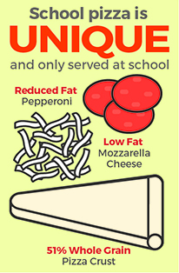More grains, more benefits.

The kinds of grains we consume determine their benefits. Simple carbohydrates like white bread metabolize quickly, breaking down into sugars that can leave students sluggish. Complex carbohydrates do much more for kids, providing them with lasting fullness and sustained energy for a full day of learning. That is why we offer products made with at least 51% whole grains—including our pizza crust!

Ready to make a grain change?

Making the switch from white to wheat can be challenging. You might even notice there can be inconsistencies between labels and ingredient lists. As you set out to choose healthier grain options, look for the following:

* 100% whole wheat flour as the first ingredient
* Low to no saturated fats
* At least 4 grams of fiber per 2-slice serving

shutterstock_287238812_screened_1.tif

We’re rethinking school meals!

Join us as we celebrate the good   
work in schools across the country.

[**www.rethinkschoolmeals.com**](http://www.rethinkschoolmeals.com)