*Logo Here.eps*

**SEPTEMBER 2015**

Fall. Family. Fun. FOOD!

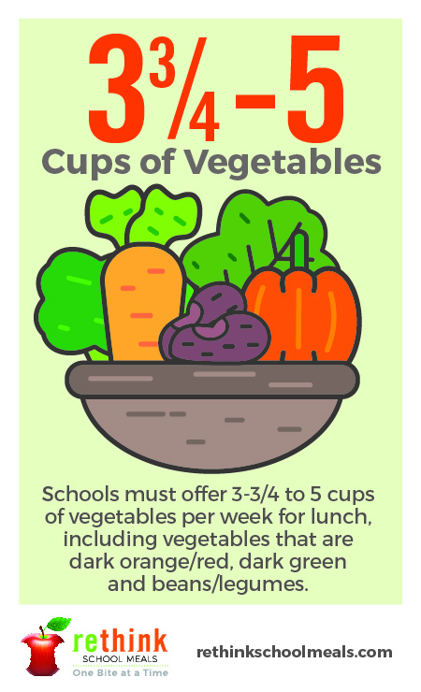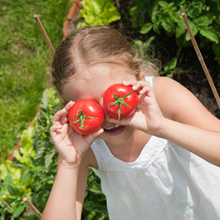Each week, we offer your student a cornucopia of vegetable options through our school meal program. Children can get what their bodies need by eating a colorful variety of vegetables, including dark oranges and reds, dark greens, and even beans and legumes. We pride ourselves on offering a healthy variety and we want to encourage you to do the same! This month, carve out some time for fall family fun! Visit your local farmers market and encourage your child to pick vegetables to include in that week’s meals. Together, we’re creating healthy habits — one vegetable at time!

“Count” on Us.

As children grow, their nutritional needs change. Our nutrition department closely follows the latest research and recommendations to make sure we’re serving kids what they need, when they need it. One important part of that equation is vegetables! For our younger students in grades kindergarten through 8, we’re offering a ¾ cup serving of vegetables each day; for grades   
9 – 12, we offer a full cup. That means we’re serving students up to 5 cups   
of vegetables each week, in a variety of colors.

Eat Your Vegetables!

We’re always telling kids to eat their vegetables, but you know that can be easier said than done… That’s why we feature each food group in a way   
that even the most persnickety students can enjoy! Vegetables are no exception. As we plan our menus, we look local. We choose seasonal. And whenever possible, we incorporate vegetables into foods we already know   
they love. The final product is a balanced plate that looks **and** tastes great.

Hunger Action Month

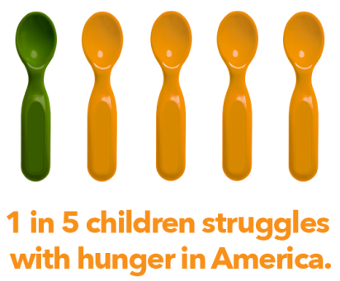September is Hunger Action Month – Feeding America’s nationwide campaign designed to raise awareness and mobilize the public to take action on the issue of hunger. Just as we tackle hunger for your students each day with a nutritious school lunch, ConAgra Foods partners with Feeding America to work to ensure every child has sufficient access to food to help them through their school day and beyond. We can all help! Join us this Hunger Action Month by encouraging your friends and family to wear orange on Thursday, September 3rd, Hunger Action Day, and visit [www.FeedingAmerica.org/HungerActionMonth](http://www.FeedingAmerica.org/HungerActionMonth) to learn how you can do more.

[**www.rethinkschoolmeals.com**](http://www.rethinkschoolmeals.com)