*Logo Here.eps*

**OCTOBER 2015**

Farm to (Lunch) Table

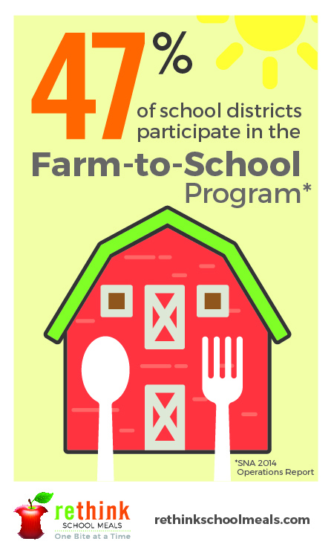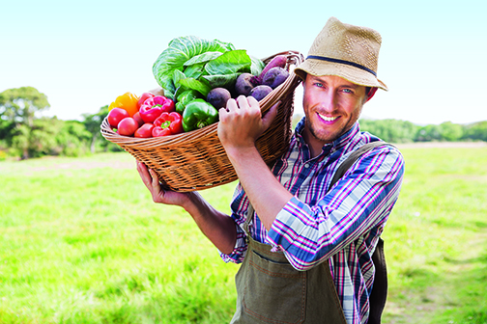You’ve heard of farm-to-table, but what about Farm-to-School? Our nutrition department is taking those same principles of farm-to-table — locally sourced food from family-operated farms — and applying it to our school meal program. The result: fresher fruits, vegetables, grains, protein, and dairy to feed our students and support area farmers. Daily or weekly, food is being delivered from farms to schools, with no stops or delays in between. This ensures we serve your children meals that look **and** taste better!

A Growing Trend

Today, 47% of U.S. schools are participating in a Farm-to-School program… And we expect that number to grow. Rethinking school meals takes a little time. It relies on making advocates out of our students and their parents! Showing them what a school meal **can** be — delicious and nutritious, packed full of colors and flavors! The Farm-to-School program is one step   
in that process. We believe that by incorporating the highest quality food   
into our menus, we can change the perception of school meals. Let us   
know how we’re doing!

Hungry to Learn More?

We’re always telling kids to eat their vegetables, but you know that can be easier said than done… That’s why we feature each food group in a way that even the most persnickety students can enjoy! Vegetables are no exception. As we plan our menus, we look local. We choose seasonal. And whenever possible, we incorporate vegetables into foods we already know they love. The final product is a balanced plate that looks **and** tastes great.

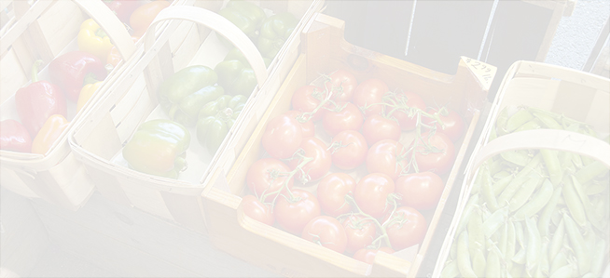

We’re rethinking school meals!

Join us as we celebrate the good   
work in schools across the country.

[**www.rethinkschoolmeals.com**](http://www.rethinkschoolmeals.com)