*Logo Here.eps*

**DECEMBER 2015**

Looking Forward to 2016

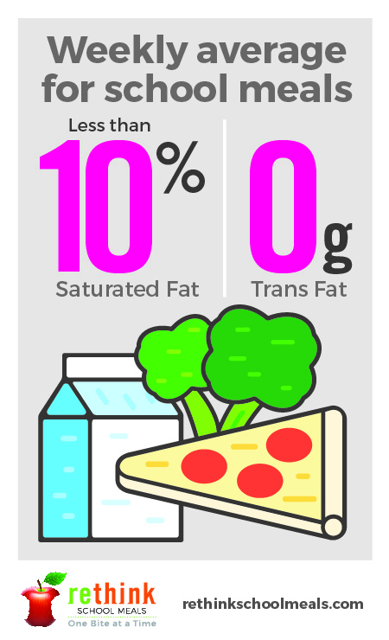The holidays bring a mix of nostalgia and anticipation. While we reflect, we also   
look forward to a new year. Our Nutrition Department is doing the same. While   
we are proud of the positive changes to our menu, we are also eager to share   
even more with students and parents in 2016. As you and your student set health goals for the new year, consider us your partners! We will continue to serve meals that incorporate colorful fruits and vegetables, at least 51% whole grains, and no trans fat. Happy Holidays and a Healthy New Year!

The Facts on Fats

As we set our resolutions, we want to encourage you and your students to think about food fats in a new way. Studies show that incorporating a mix of good fats into your diet actually helps maintain a healthier body weight **and** boosts brainpower! Good fats include dairy, fish, eggs, nuts, and some oils. Not only do we incorporate these into our monthly menus, we also offer reduced fat dairy options. And we keep bad fats in check—serving less than 10% in saturated fats and never trans fats.

Happy AND Healthy

Holiday meals are often a time we splurge, but a couple small changes could keep everyone happier and healthier this season:

* Before you start cooking, put some pep in your step with a family walk or run.
* Start with a healthy appetizer like fresh fruits and vegetables.
* Drink plenty of water.
* And consider a couple menu swaps where you can… Incorporate reduced fat dairy in your cooking and serve at least as many vegetables as you do starches!



We’re rethinking school meals!

Join us as we celebrate the good   
work in schools across the country.

[**www.rethinkschoolmeals.com**](http://www.rethinkschoolmeals.com)