**Logo Here.epsAUGUST 2015**

Time Saving Tip

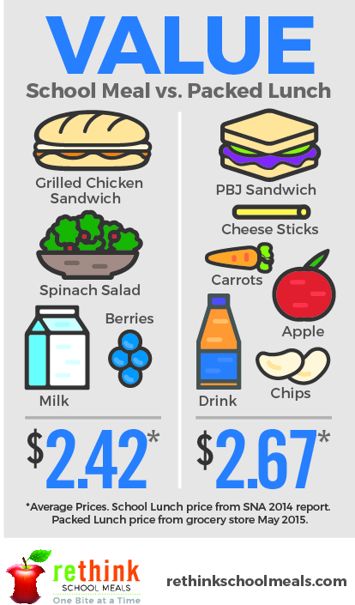We know Back to School is such a busy time for parents. The weeks leading up to that first day are usually spent buying school supplies and packing back packs—all before the homework even starts. Which is why we want to share this time saving tip: take advantage of our school meal program! Each day our nutrition department serves up balanced meals designed to help your student power through their school day. As you   
enter this busy Back to School season, we think planning lunches should be a no-brainer… Let us do the cooking instead!

School Meals Make “Cents”!

Not only does buying a meal at school save parents the time it takes to pack a lunch, it also saves you money! Did you know the lunches we provide typically save parents $.25 a day compared to the average packed lunch? A quarter a day over the course of a school year really adds up! Plus, our nutrition team plans meals based on national research and recommendations — so we know what students like to eat and what they need to succeed. Time and money saved? Sounds like a winning equation!

Creative Menus Designed to Please

We know value is only one part of the equation—and what we’re really proud of is the menu itself! Our nutrition department works hard to make sure we’re serving meals that are nutritious and delicious. We love getting creative in the kitchen—coming up with dishes that are designed to please picky palates. Each day, it’s our privilege to serve your student food that fuels their body and mind. We know that’s an important job that starts at home and our nutrition team is honored to contribute to your student’s overall health!



We’re rethinking   
school meals!  
Join us as we celebrate the good work in schools across the country.

[**www.rethinkschoolmeals.com**](http://www.rethinkschoolmeals.com)